

Course Code: CBS3005
Course Title: Cloud, Microservices and Applications
Class Number: VL2025260105679
Lab Assessment - 4
Name: Atharva Khachane
Reg No: 22BBS0155

Q. A company wants to deploy a secure, scalable, and highly available web application on AWS for global users. Perform the following tasks in AWS and submit screenshots of each step as evidence:
(i) Launch multiple EC2 instances (web servers) and configure them in different Availability Zones.
(ii) Create an Application Load Balancer (ALB) to distribute traffic across these instances.
(iii) Configure health checks so that faulty instances are automatically removed from load balancing.
(iv) Enable Auto Scaling to add/remove instances based on traffic demand.
(v) Configure path-based routing: /auth requests go to the authentication service, /order requests go to the order processing service. Integrate the Load Balancer with Route 53 so that global users are routed to the nearest AWS region.

- SOLUTION:
(i) Launch multiple EC2 instances (web servers) and configure them in different Availability Zones.
Initial: 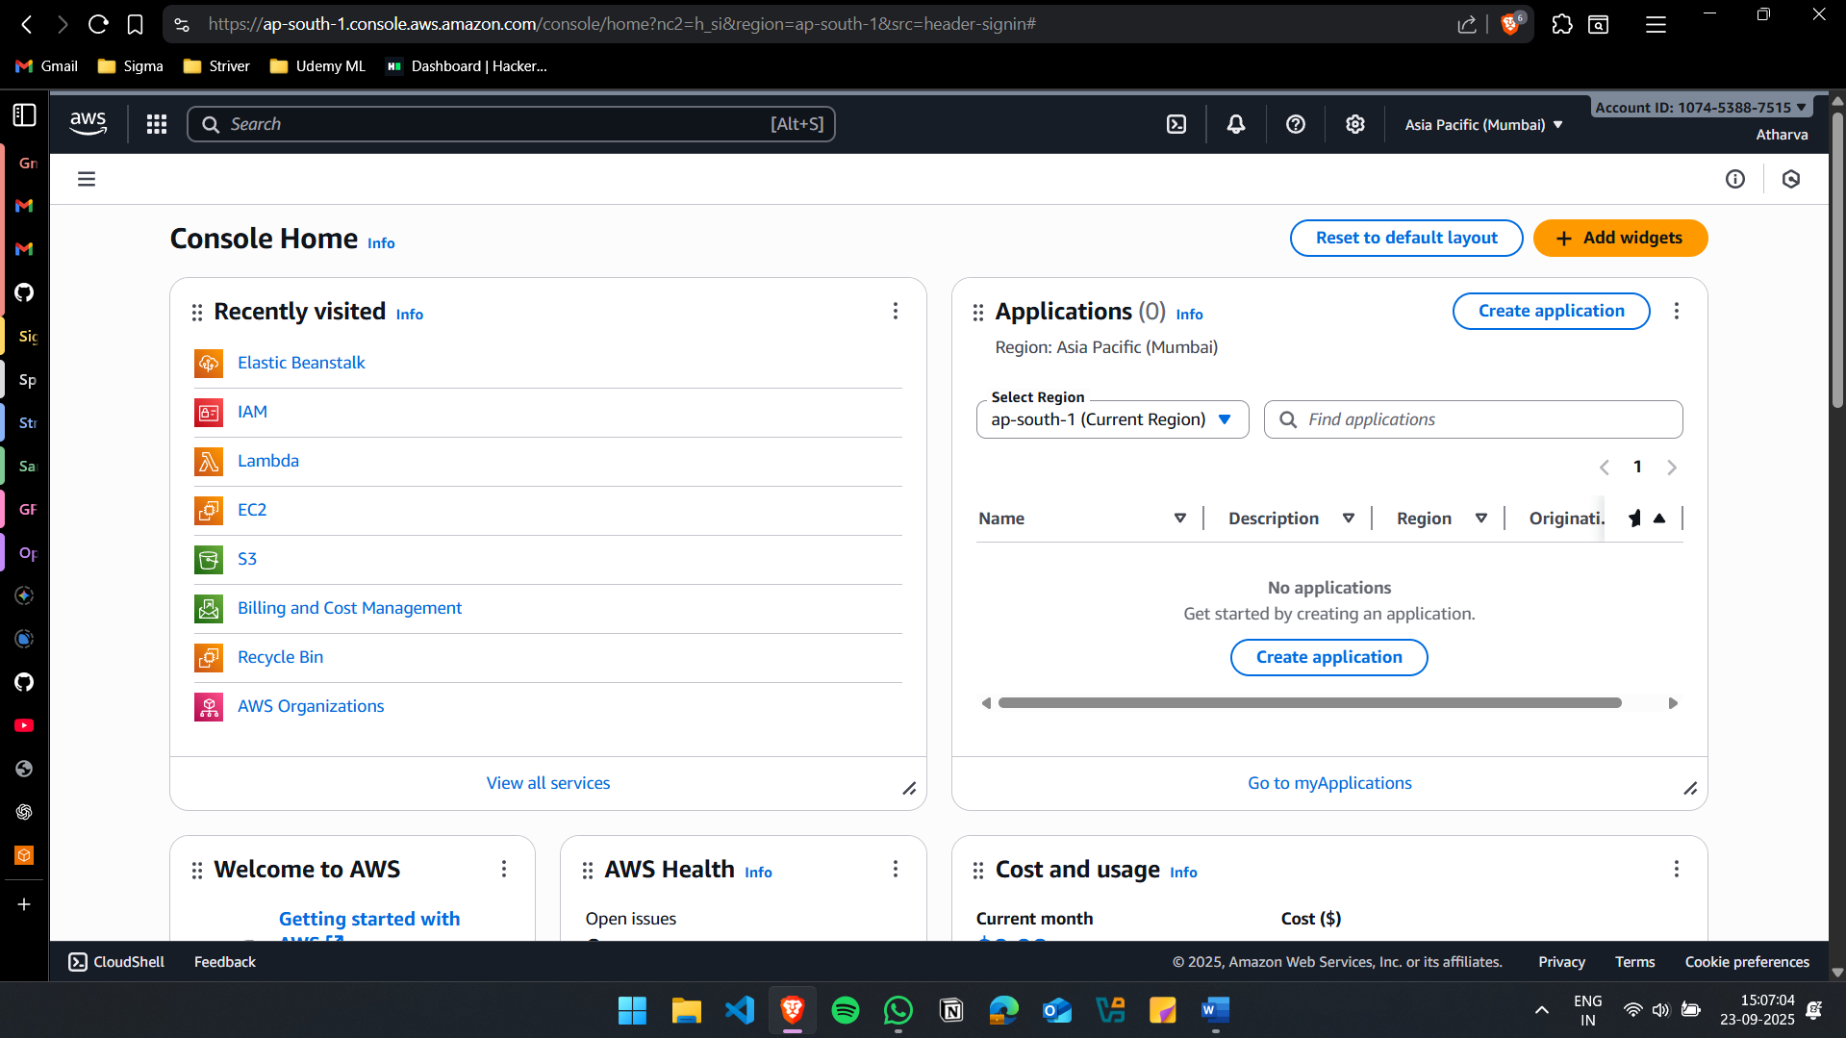

Create 2 security group for the instances:
alb-22bbs0155: For Automatic Load Balancer
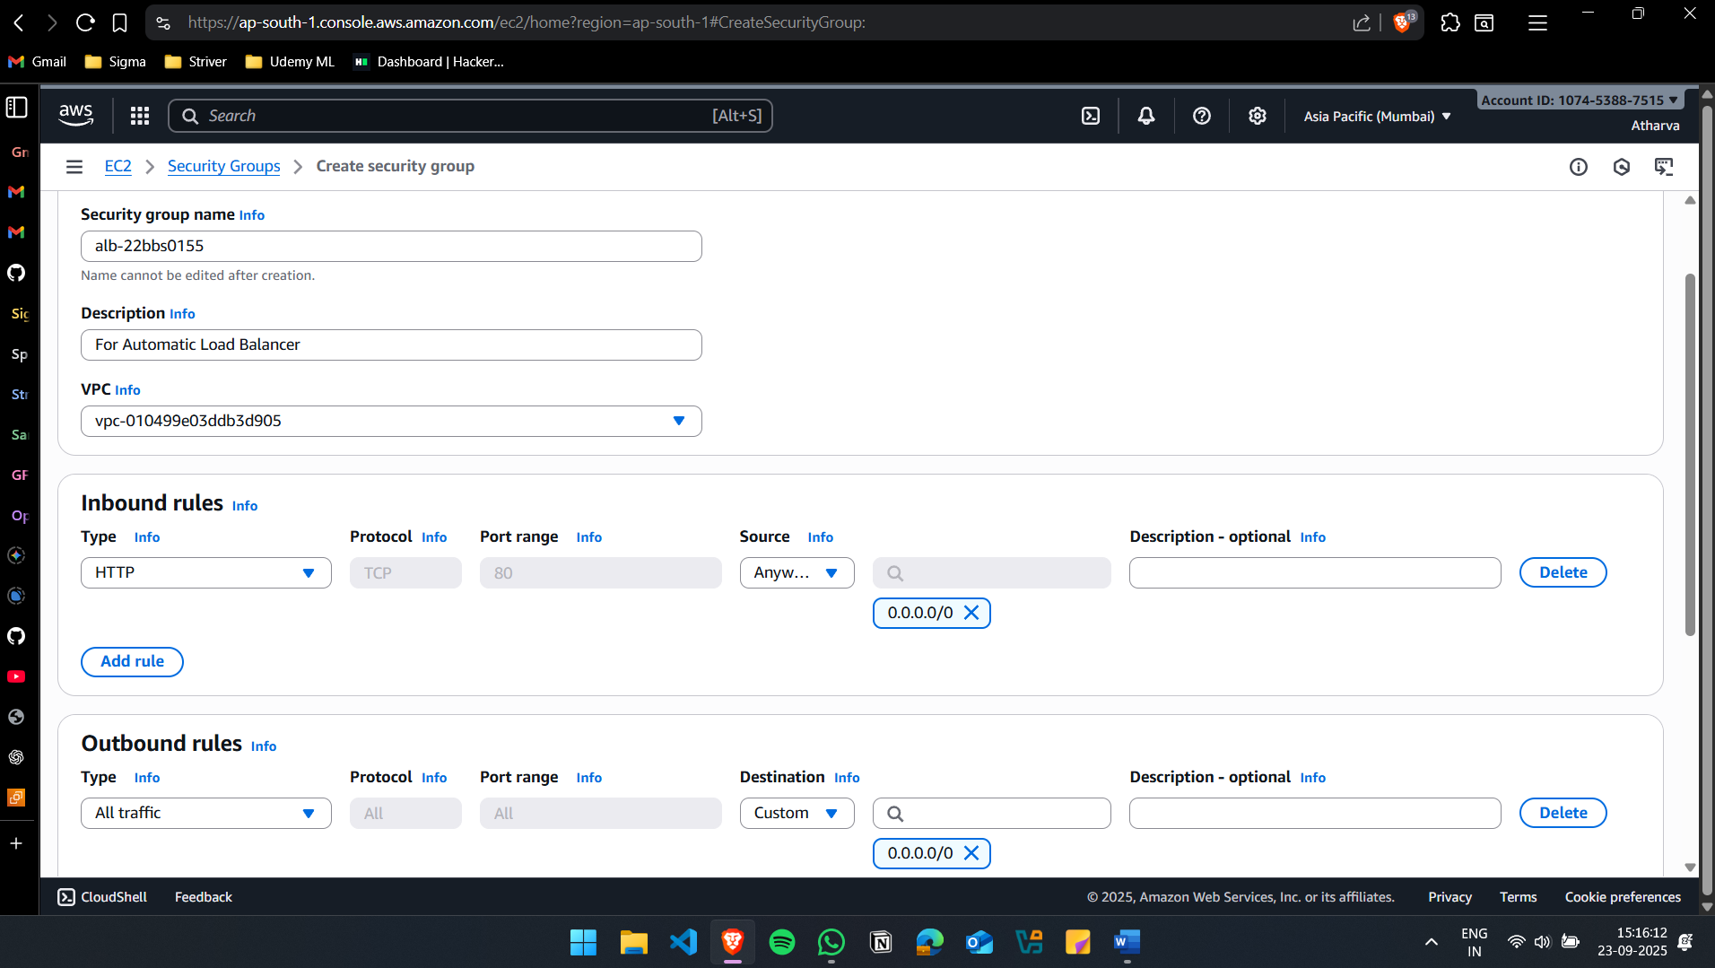

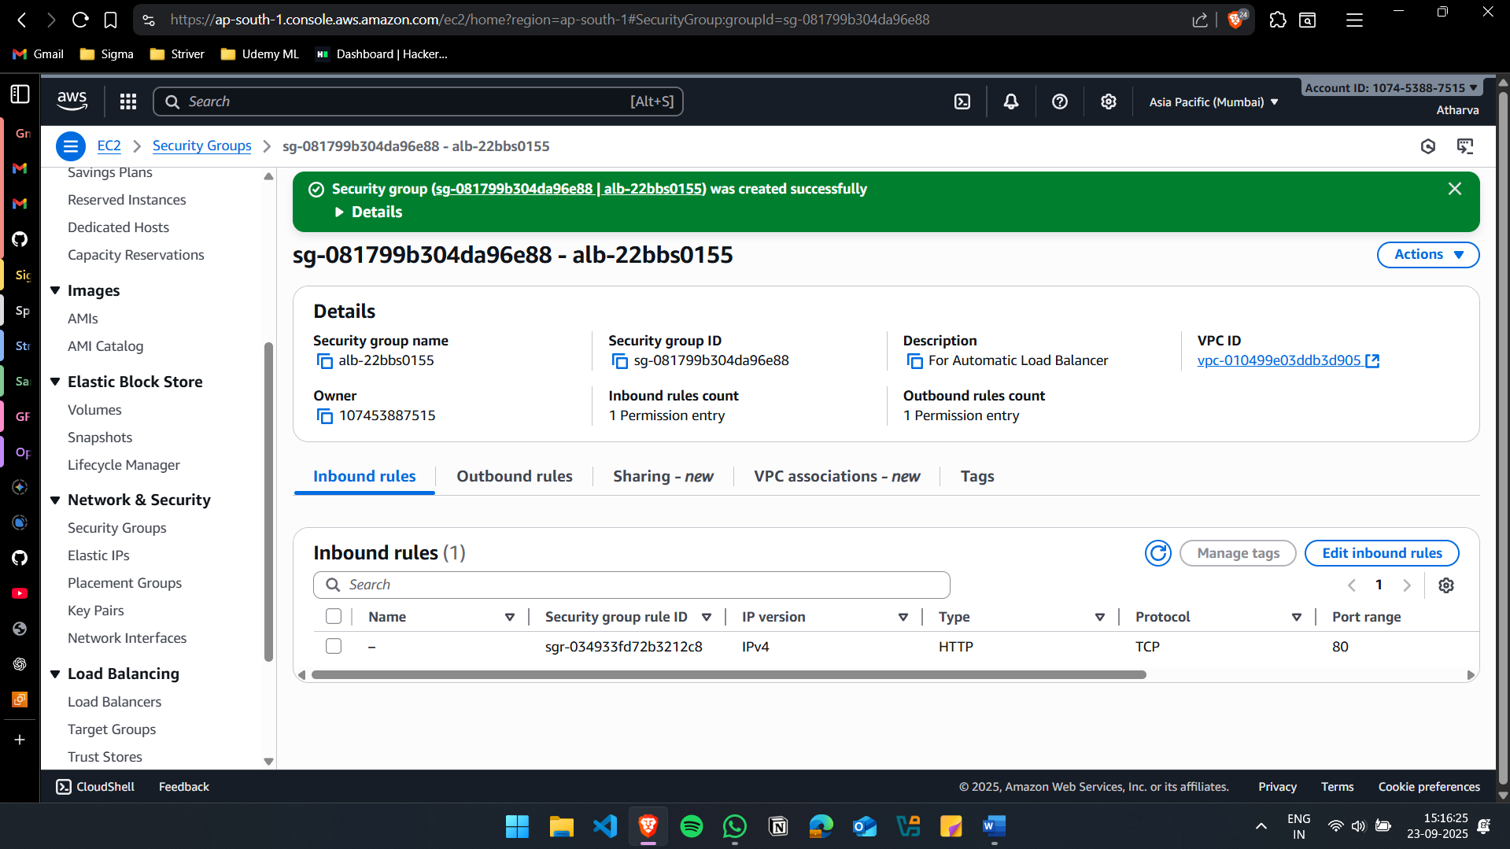

web-22bbs0155: For Web Server
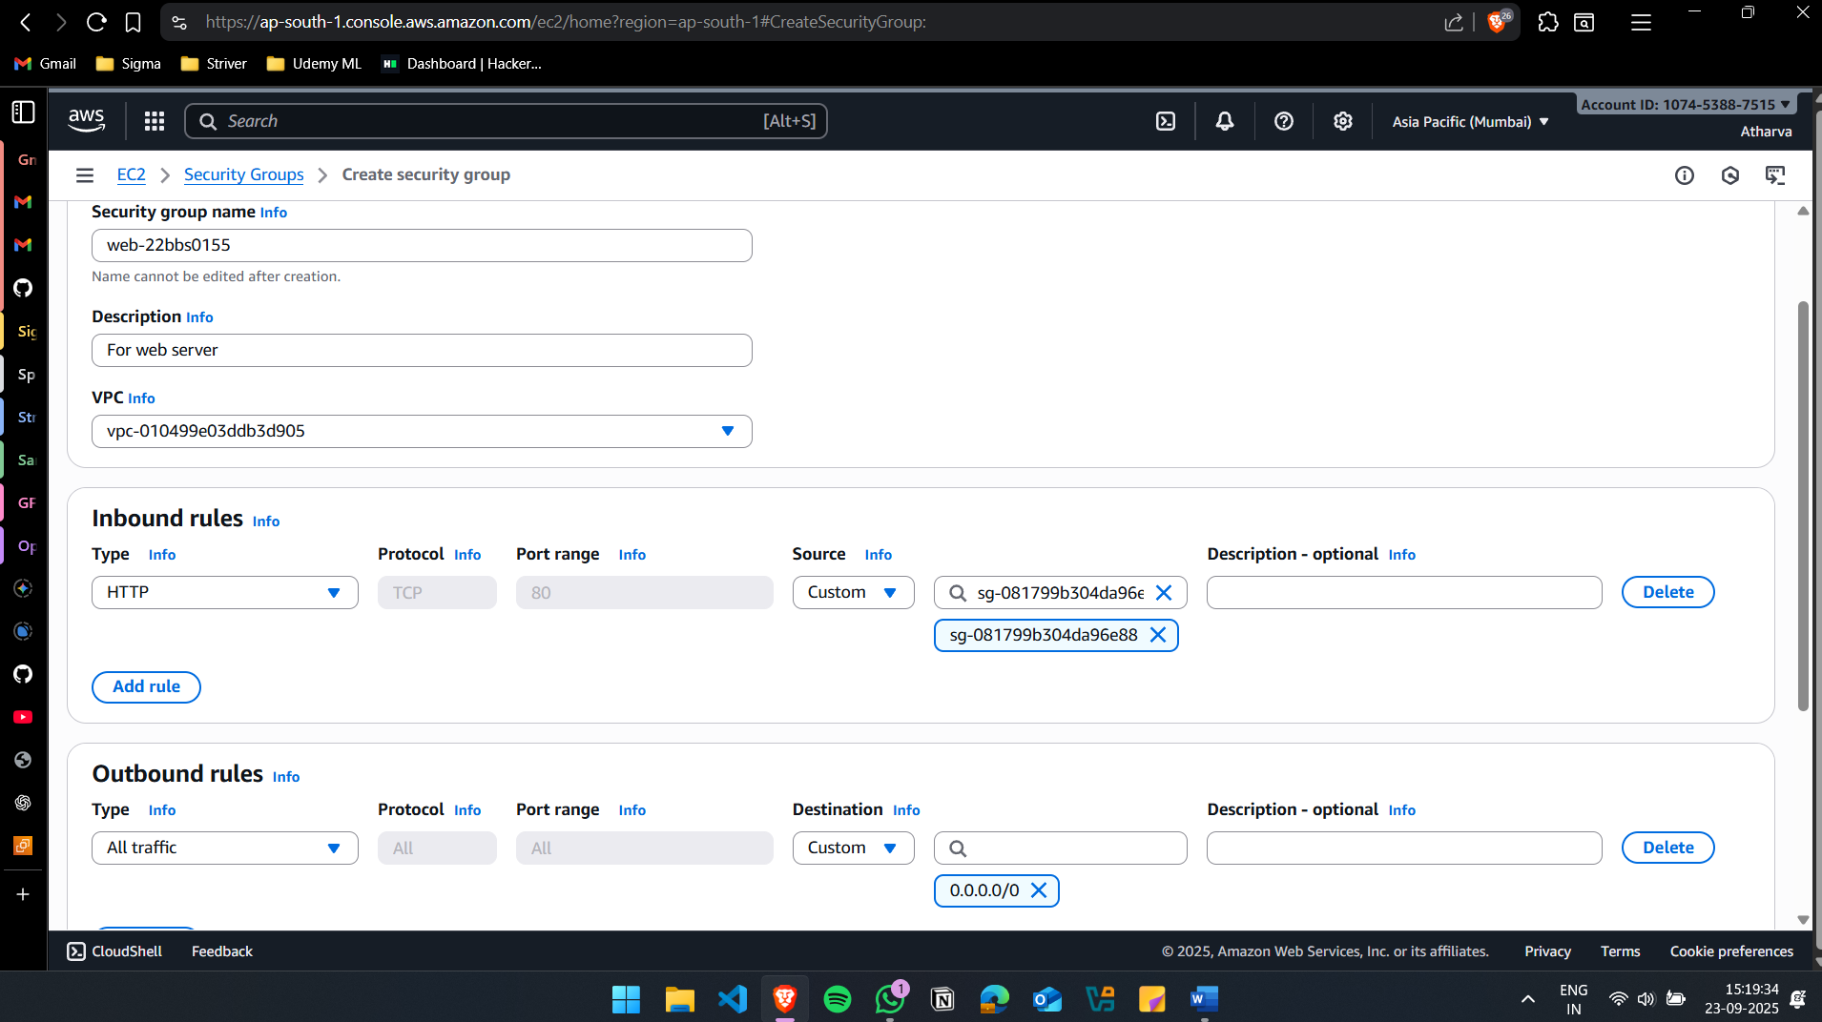

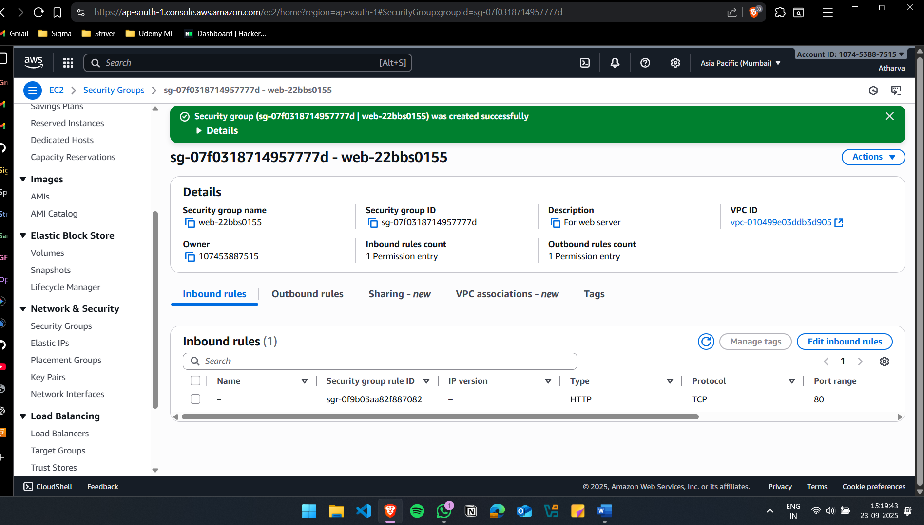
The web server can have inbound only from the sg-alb

Create 2 EC2 Instances in different AZ
web-a-22bbs0155: AZ = ap-south-1a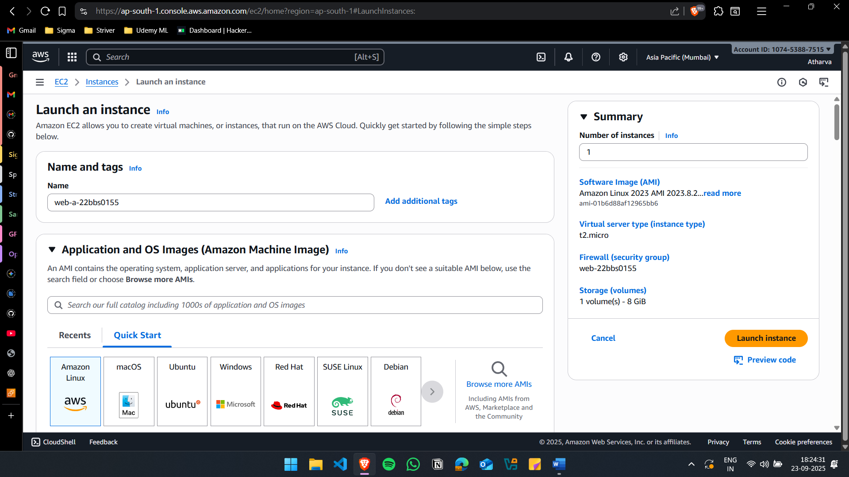

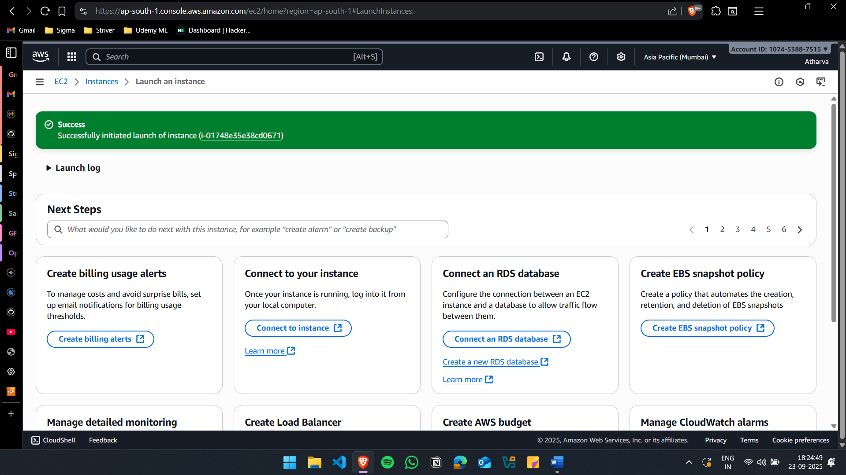

web-b-22bbs0155: AZ = ap-south-1b
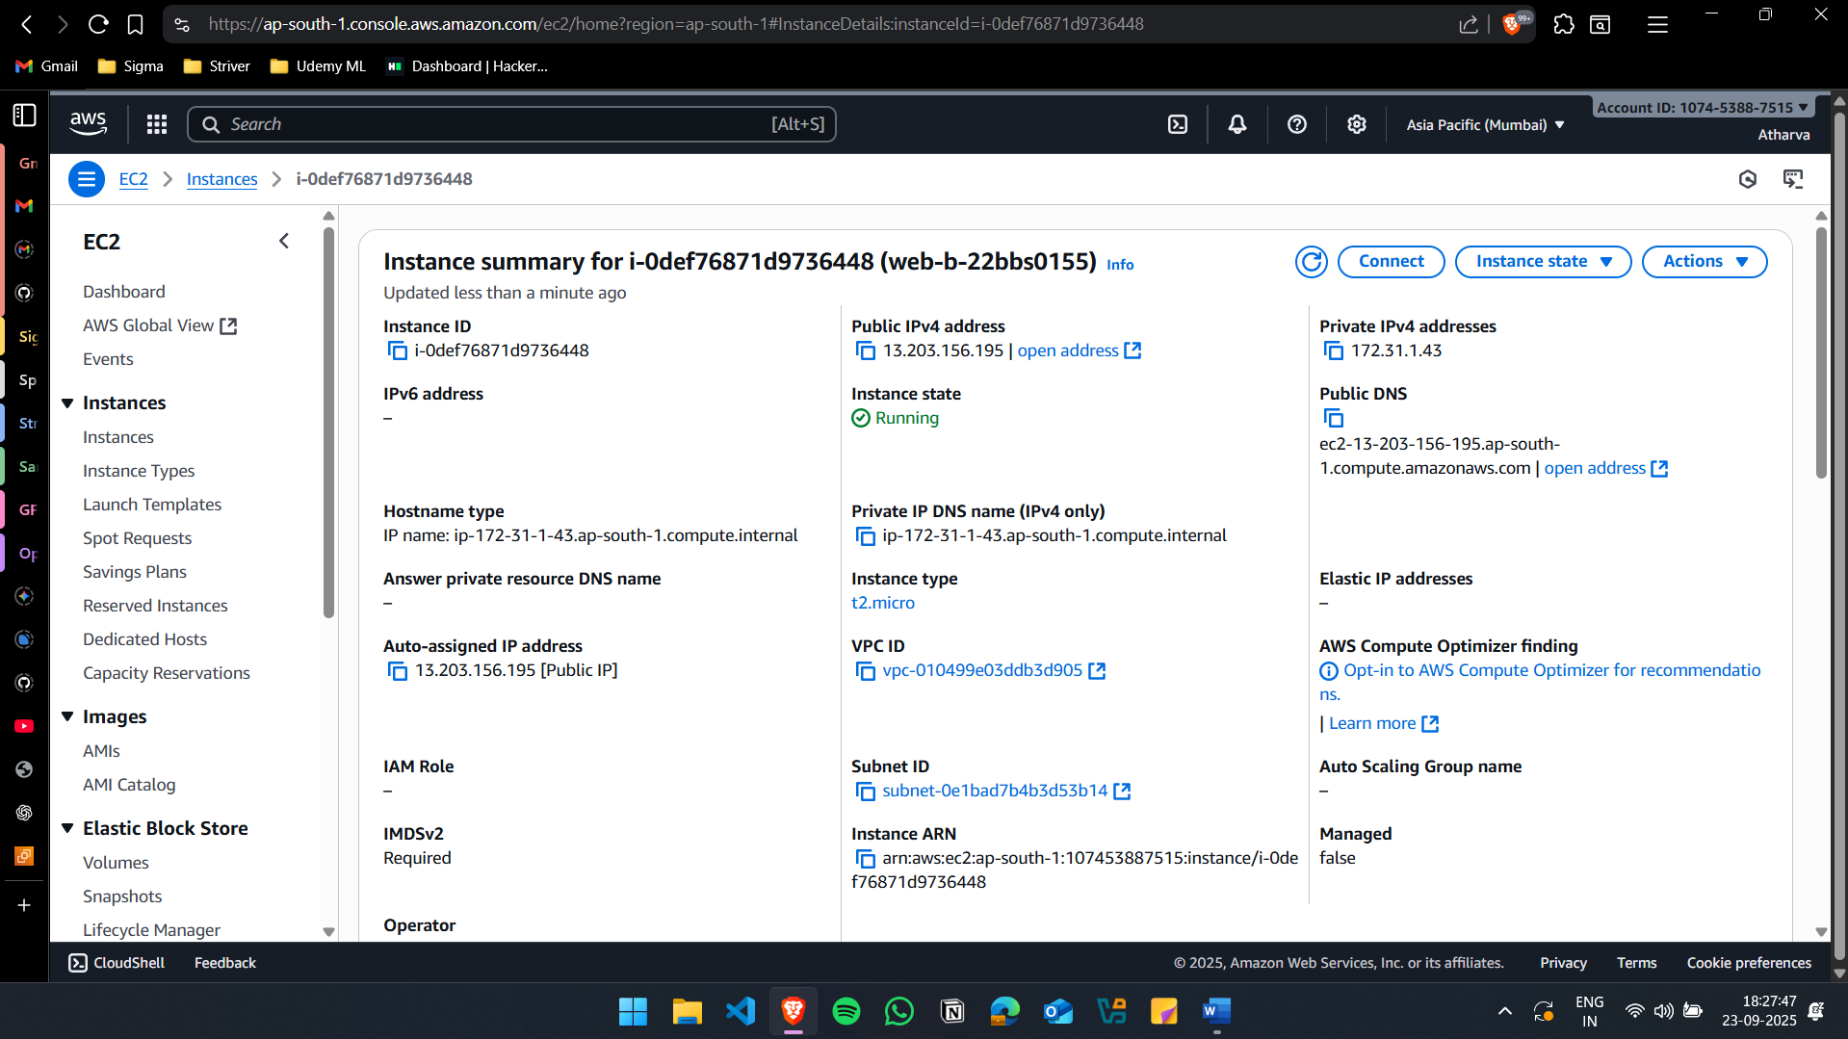

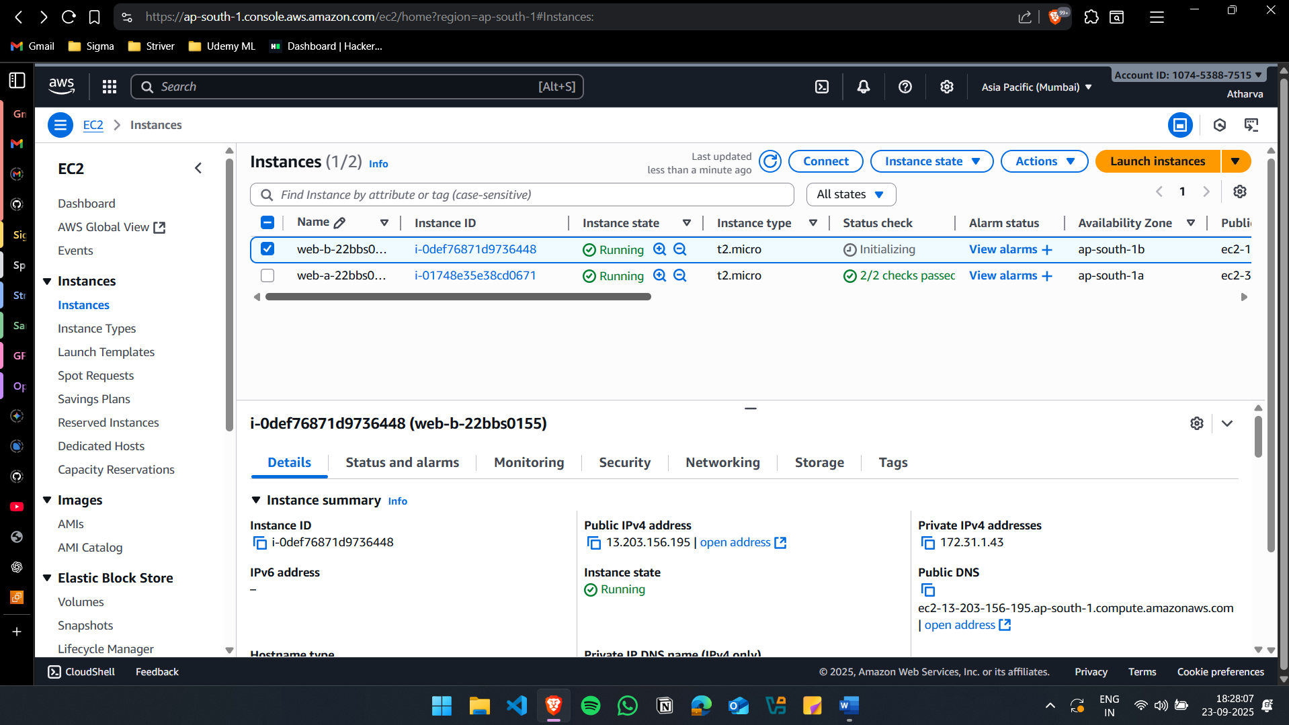

(ii) Create an Application Load Balancer (ALB) to distribute traffic across these instances.
Create Target Group
tg-webapp-22bbs0155
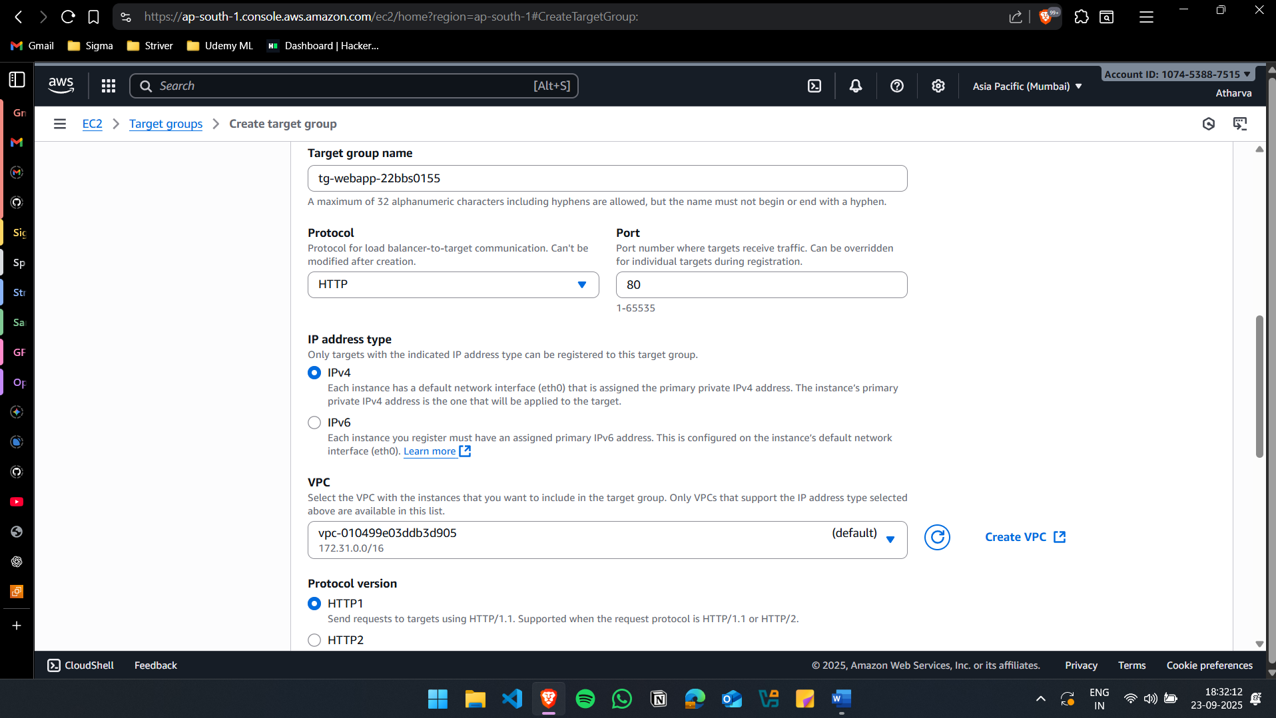

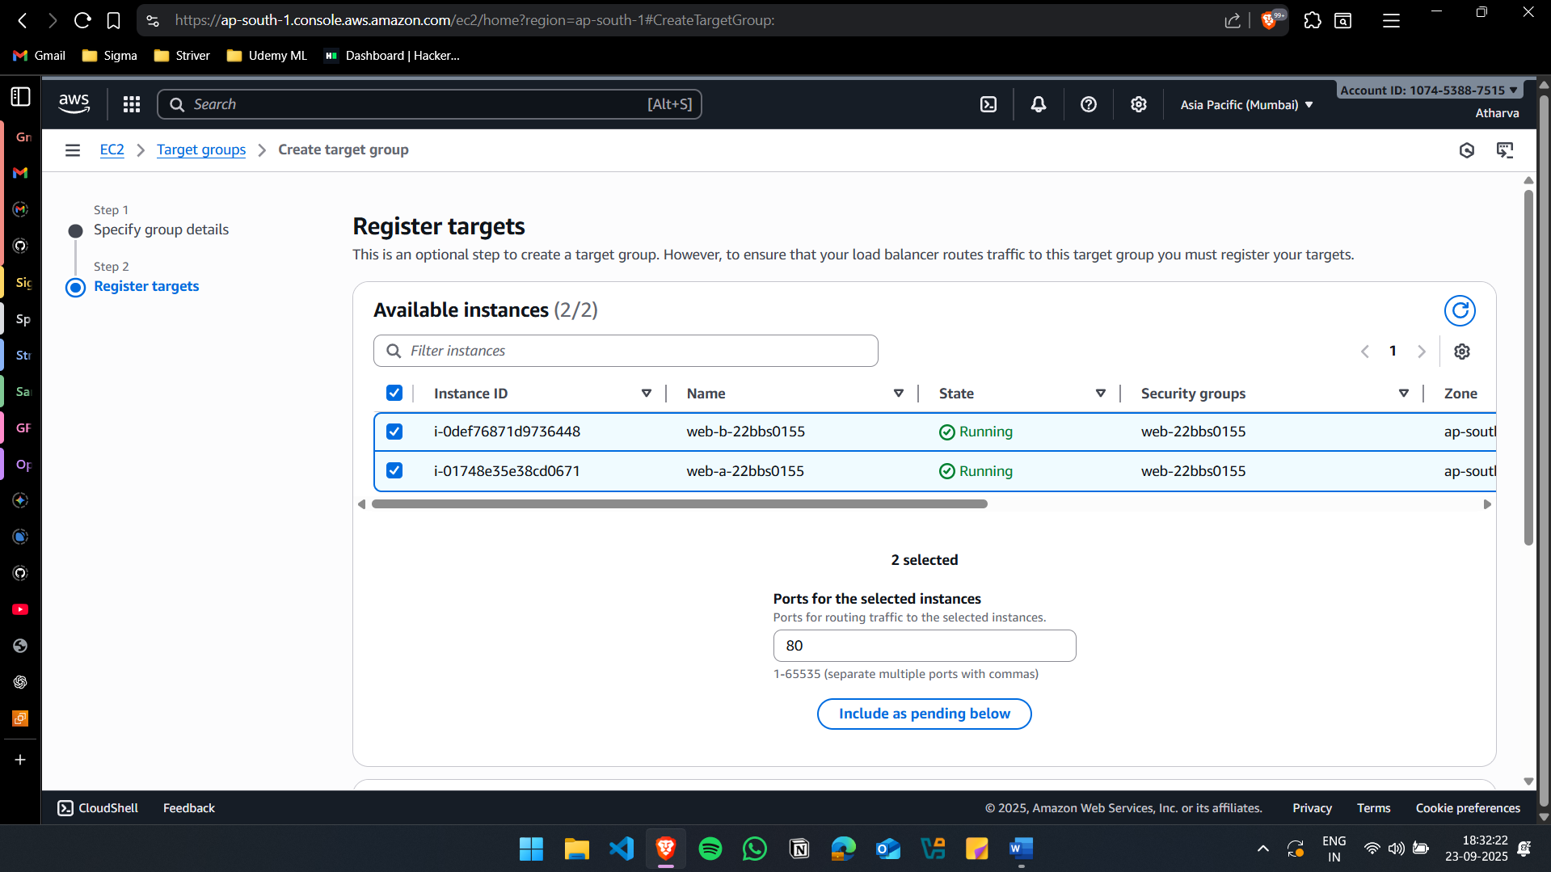

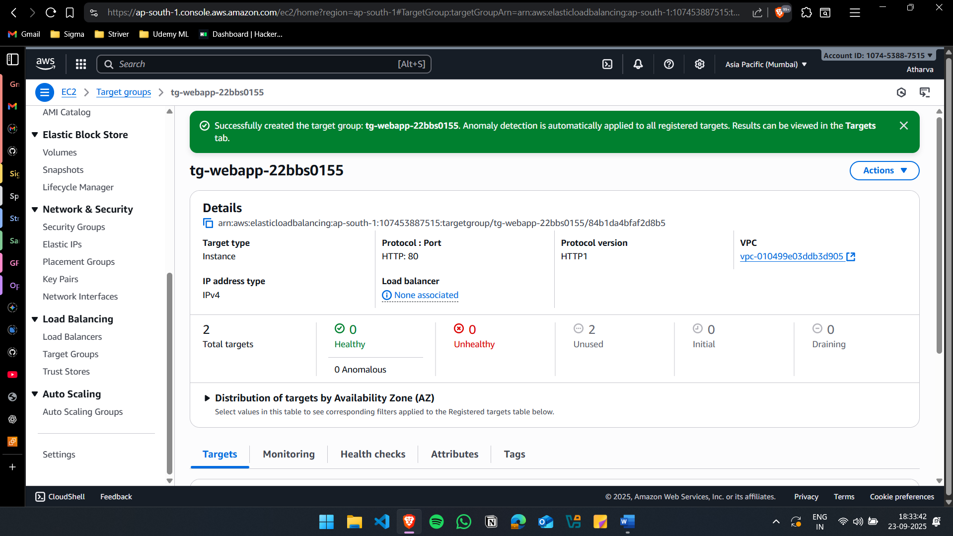

Create the Automatic Load Balancer
alb-web-22bbs0155
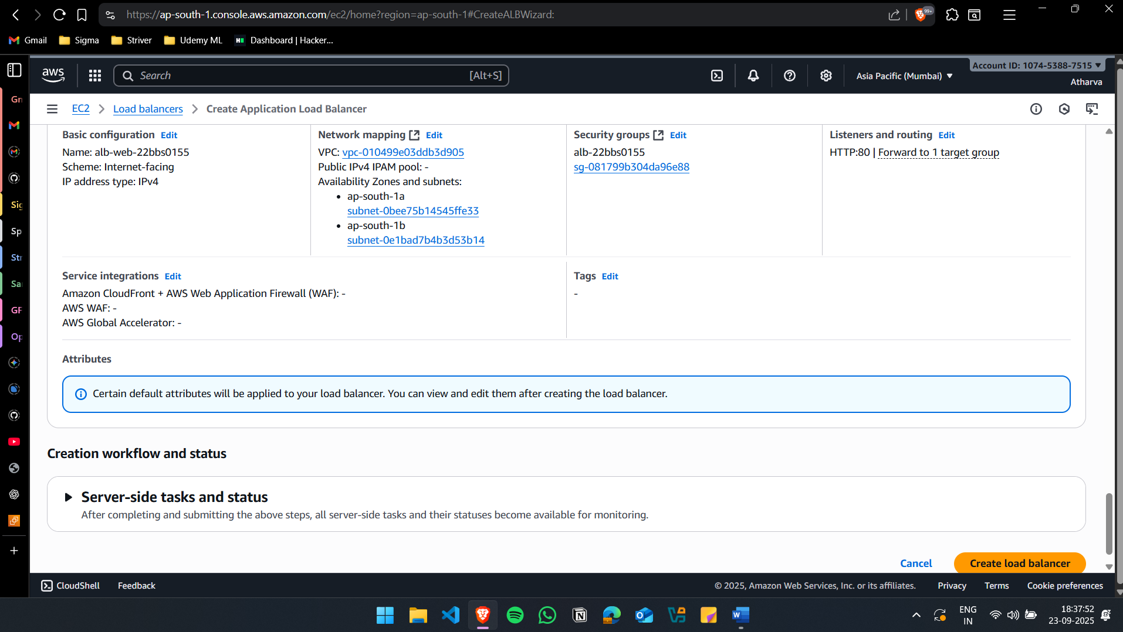
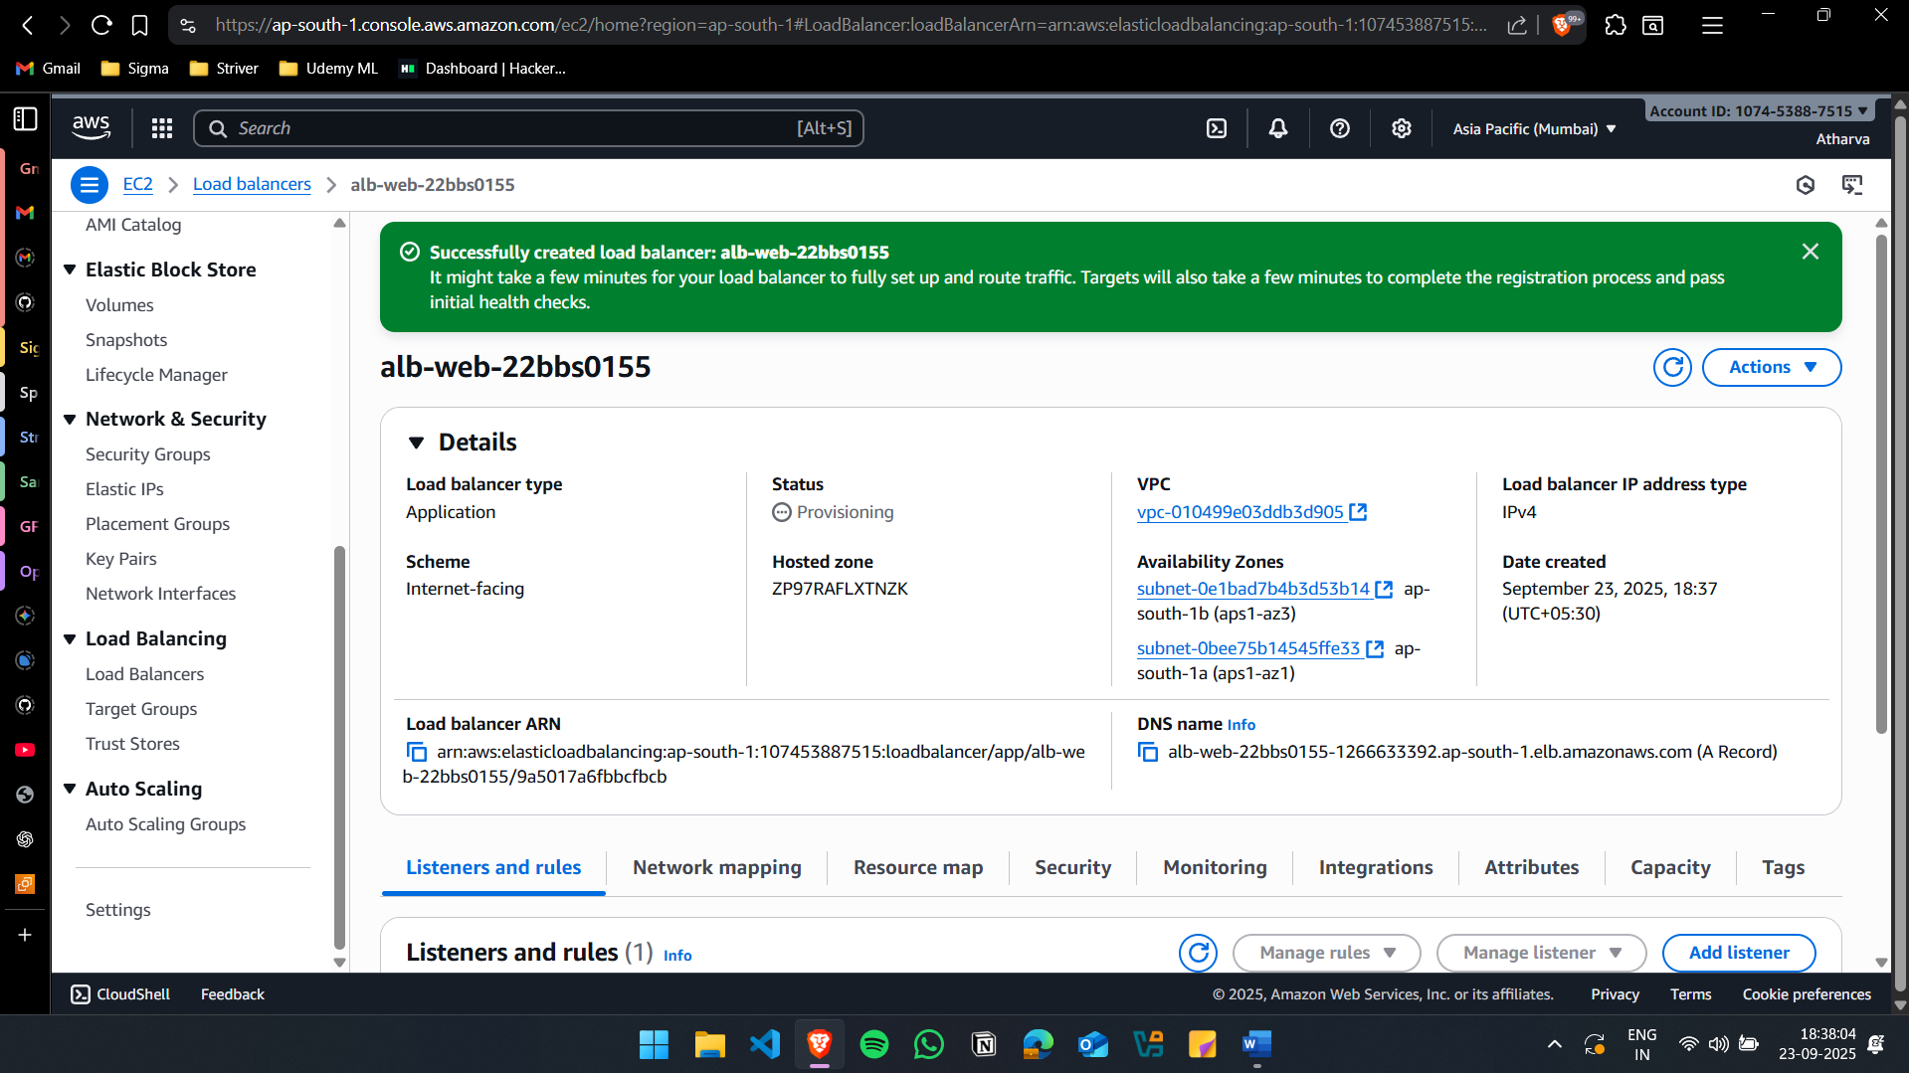

Accessing the Files from the ALB DNS (After refreshing)
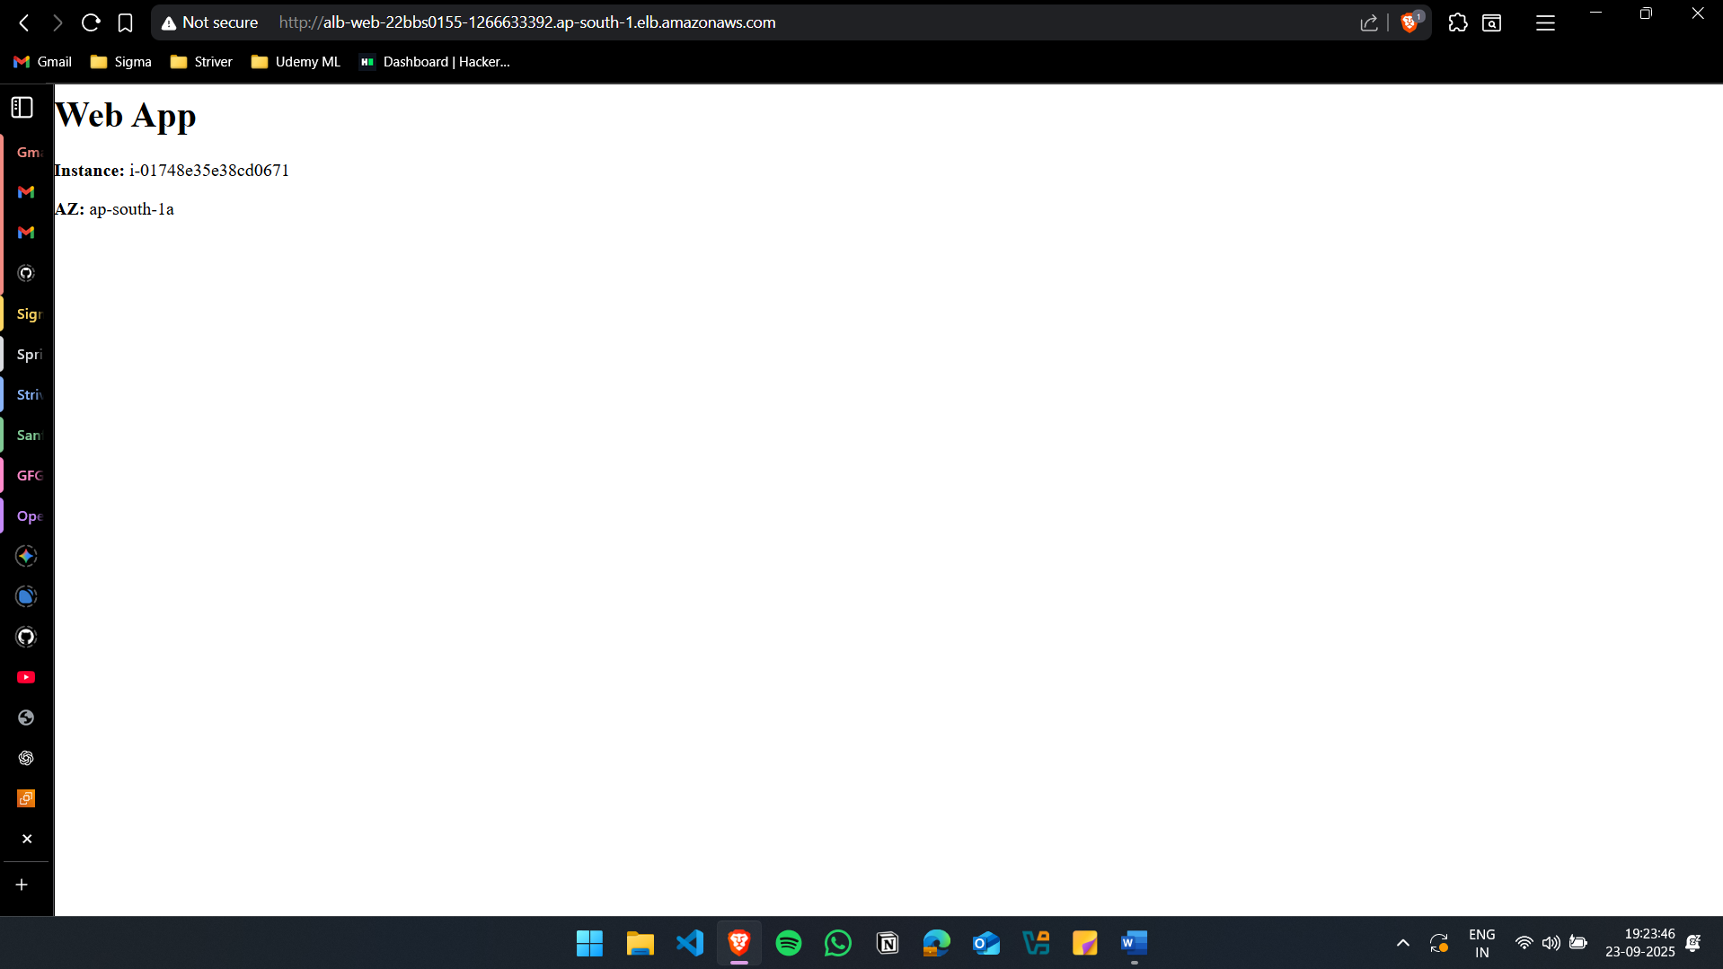\

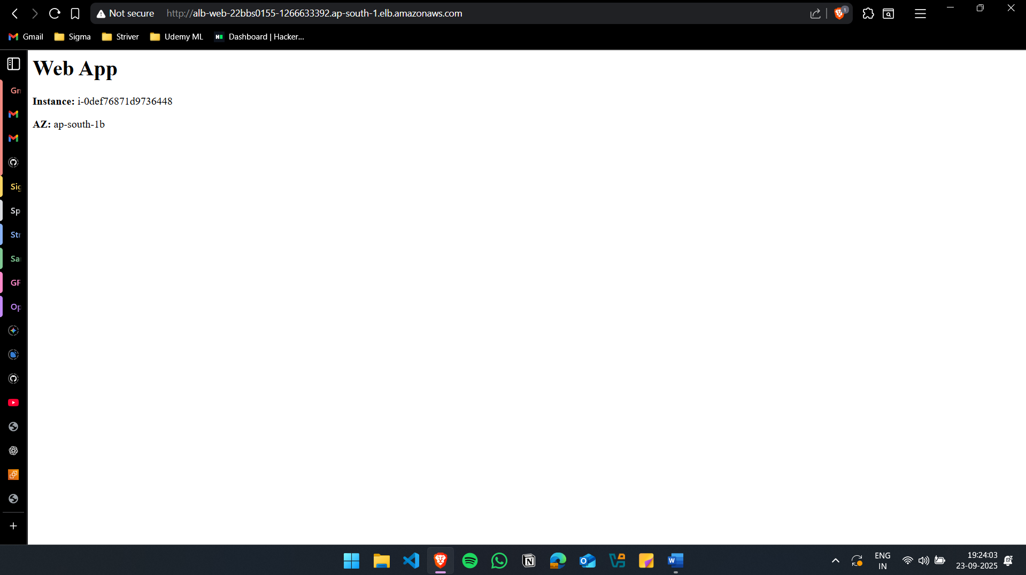

(iii) Configure health checks so that faulty instances are automatically removed from load balancing.
Edit Health Check Settings
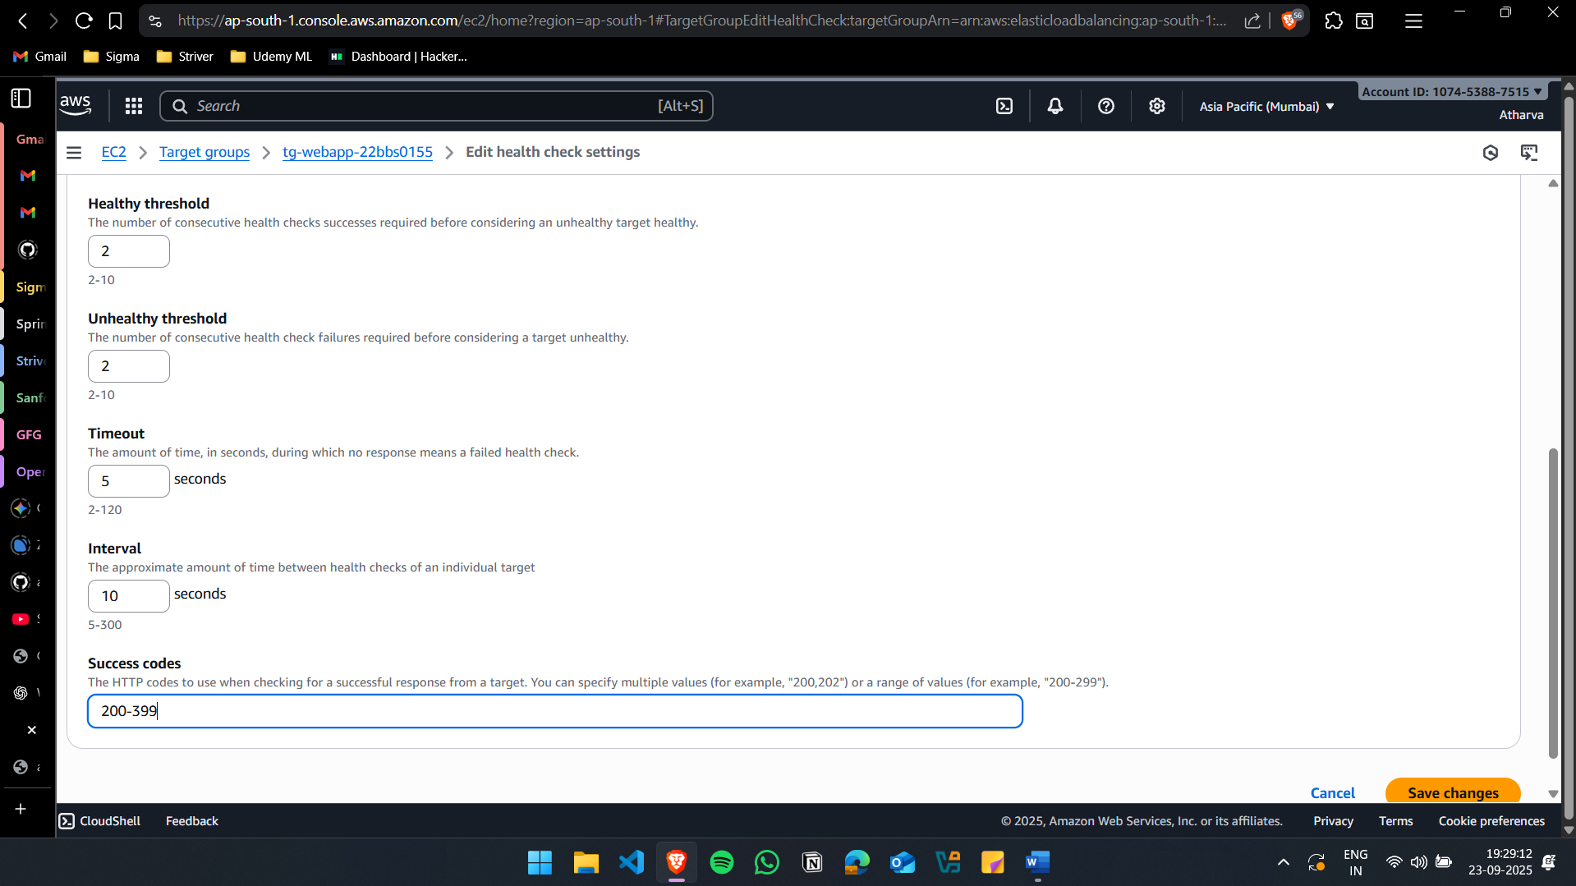

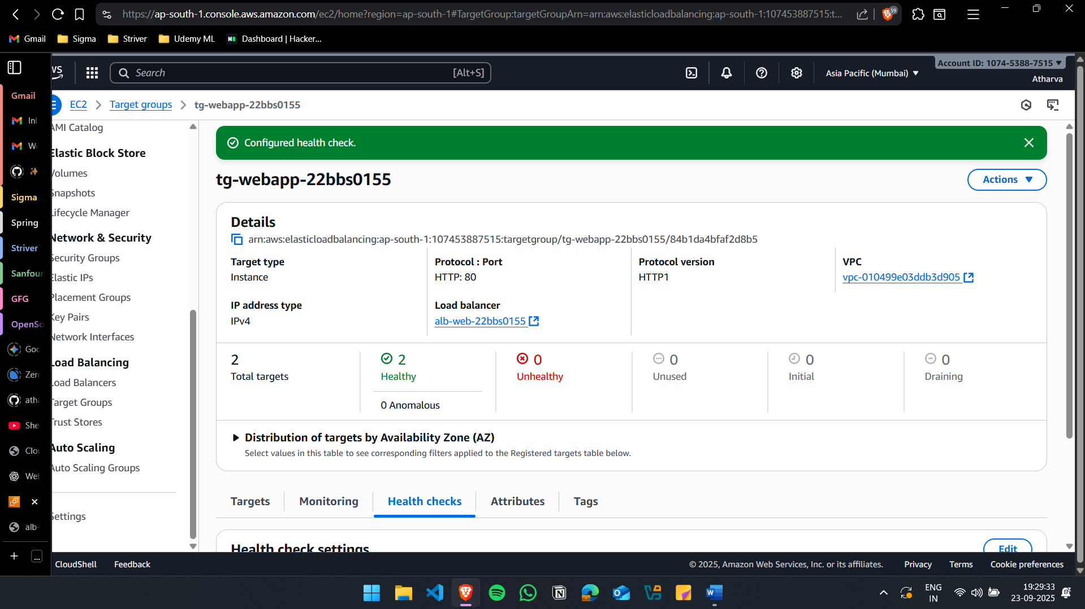

(iv) Enable Auto Scaling to add/remove instances based on traffic demand.
Create Launch Template
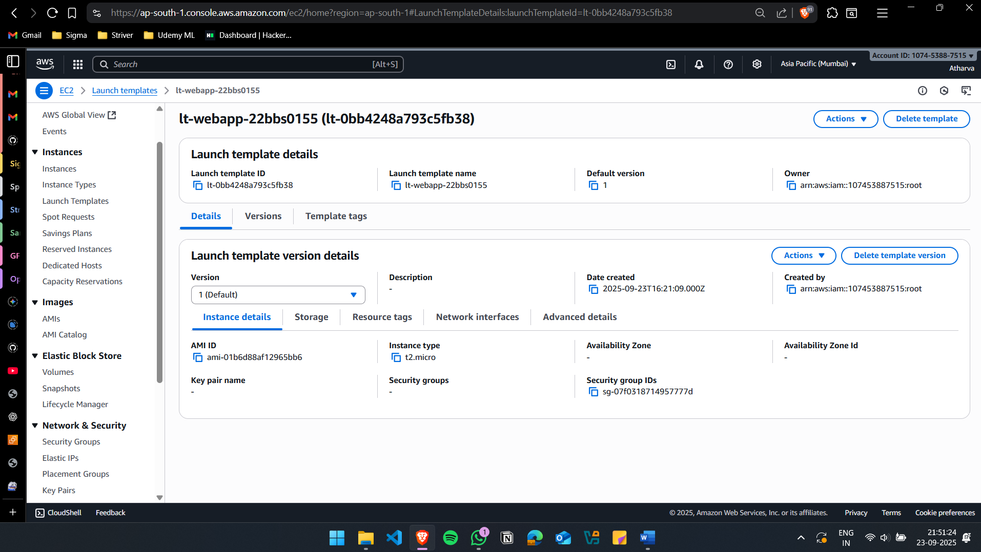
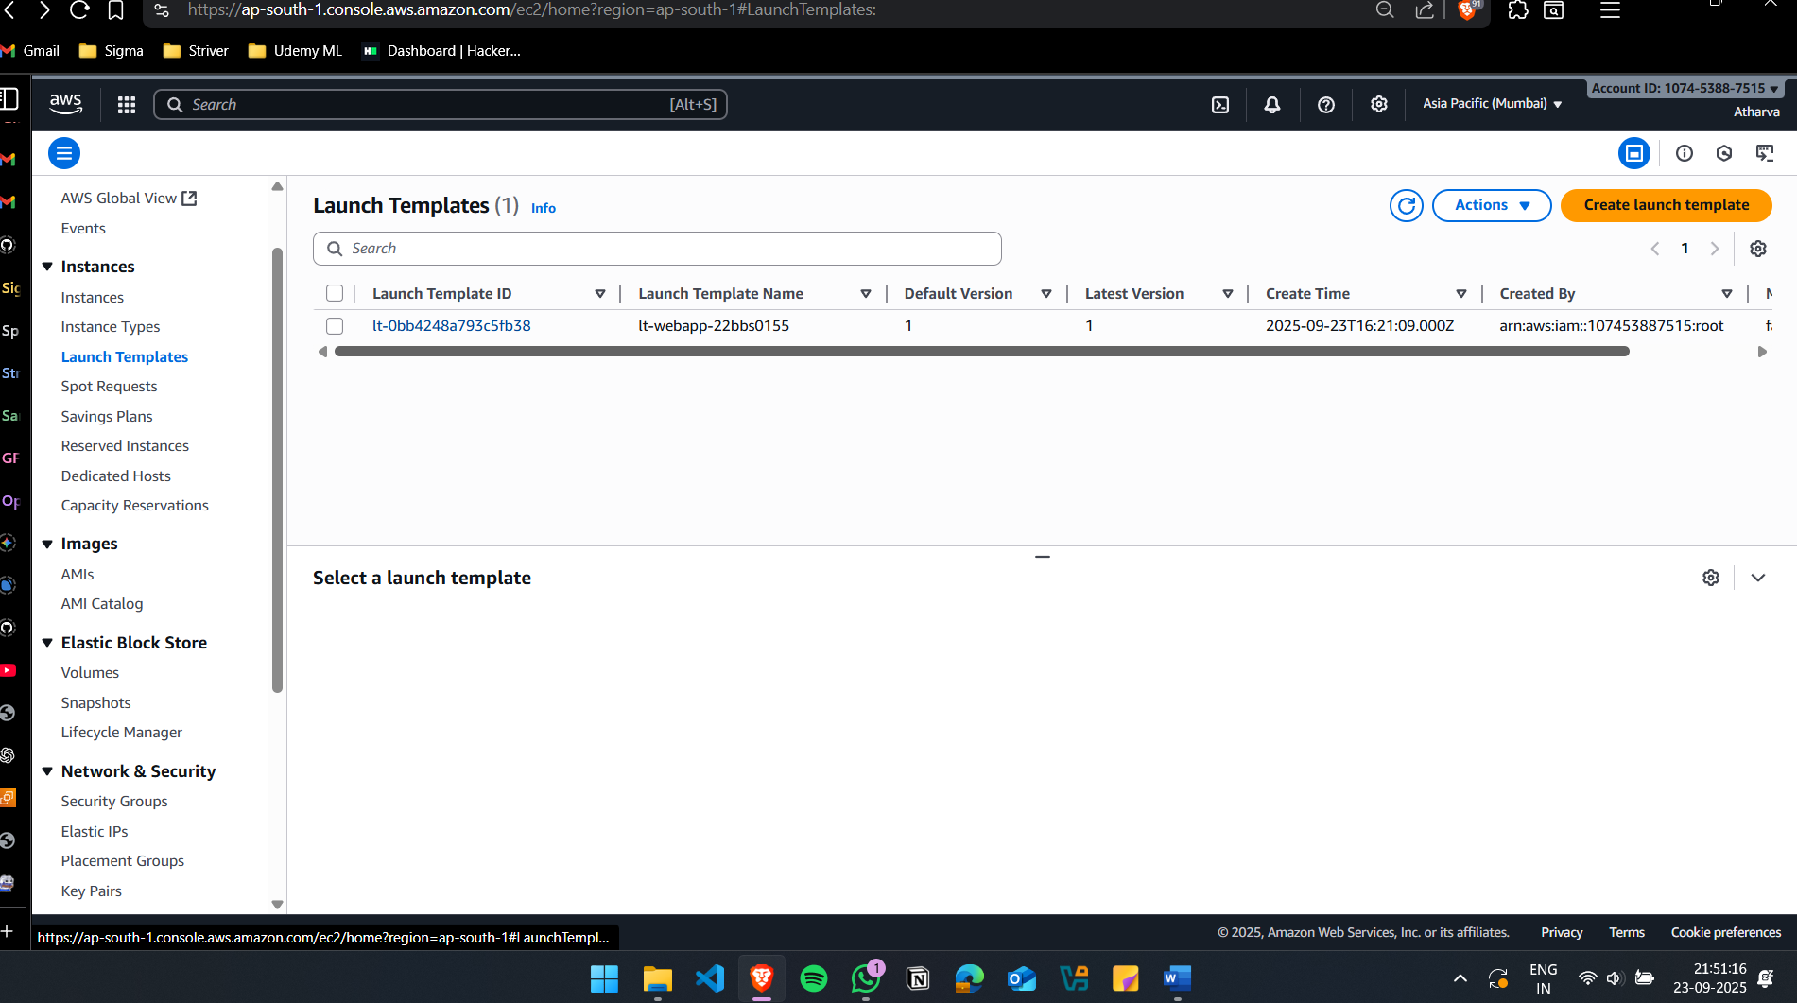

Create Auto Scaling Groups
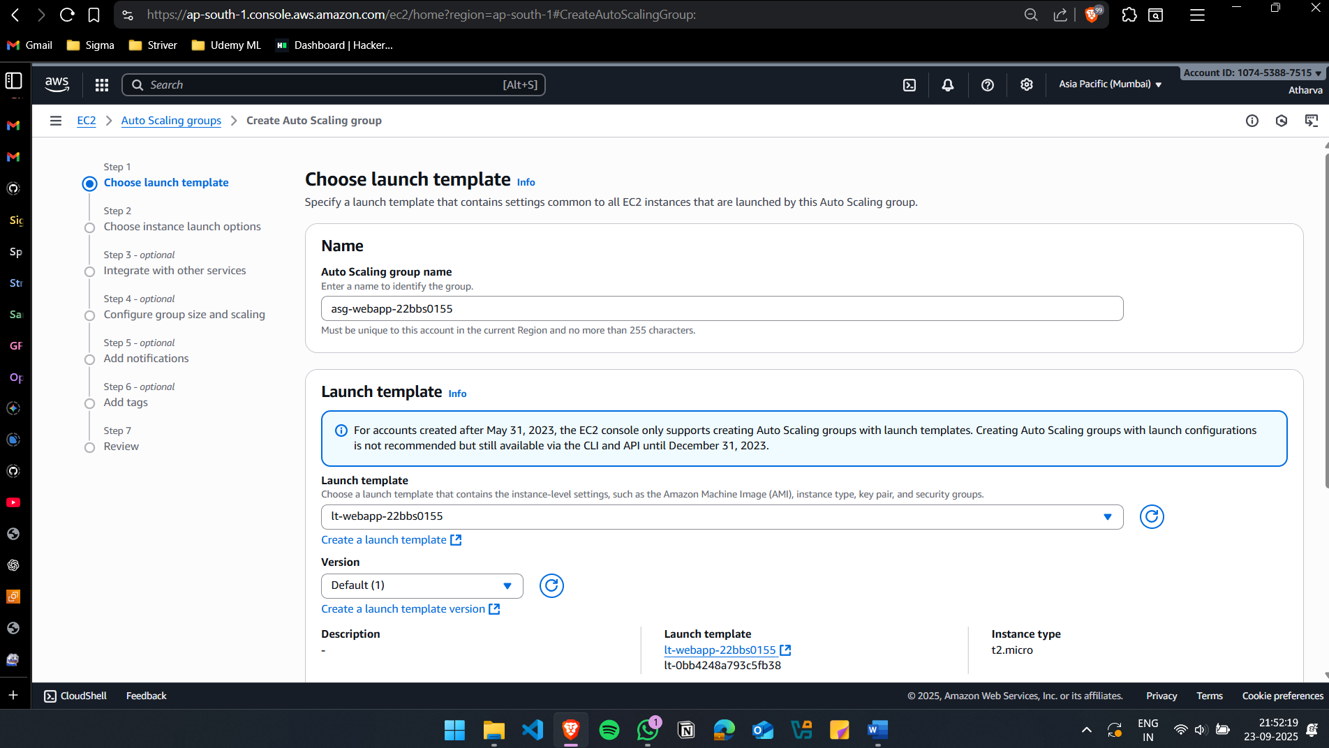
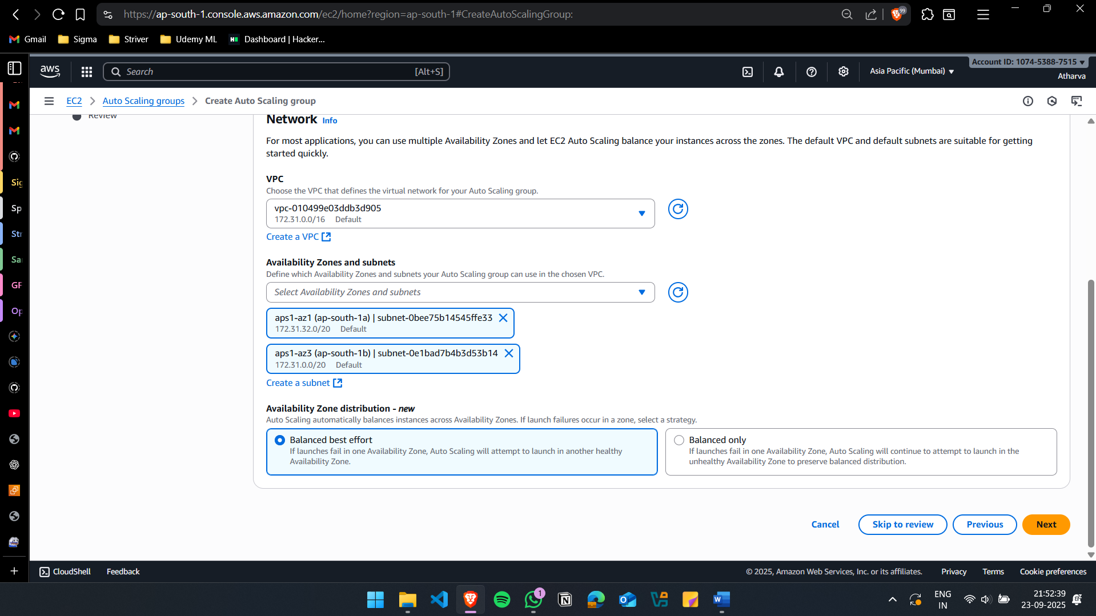
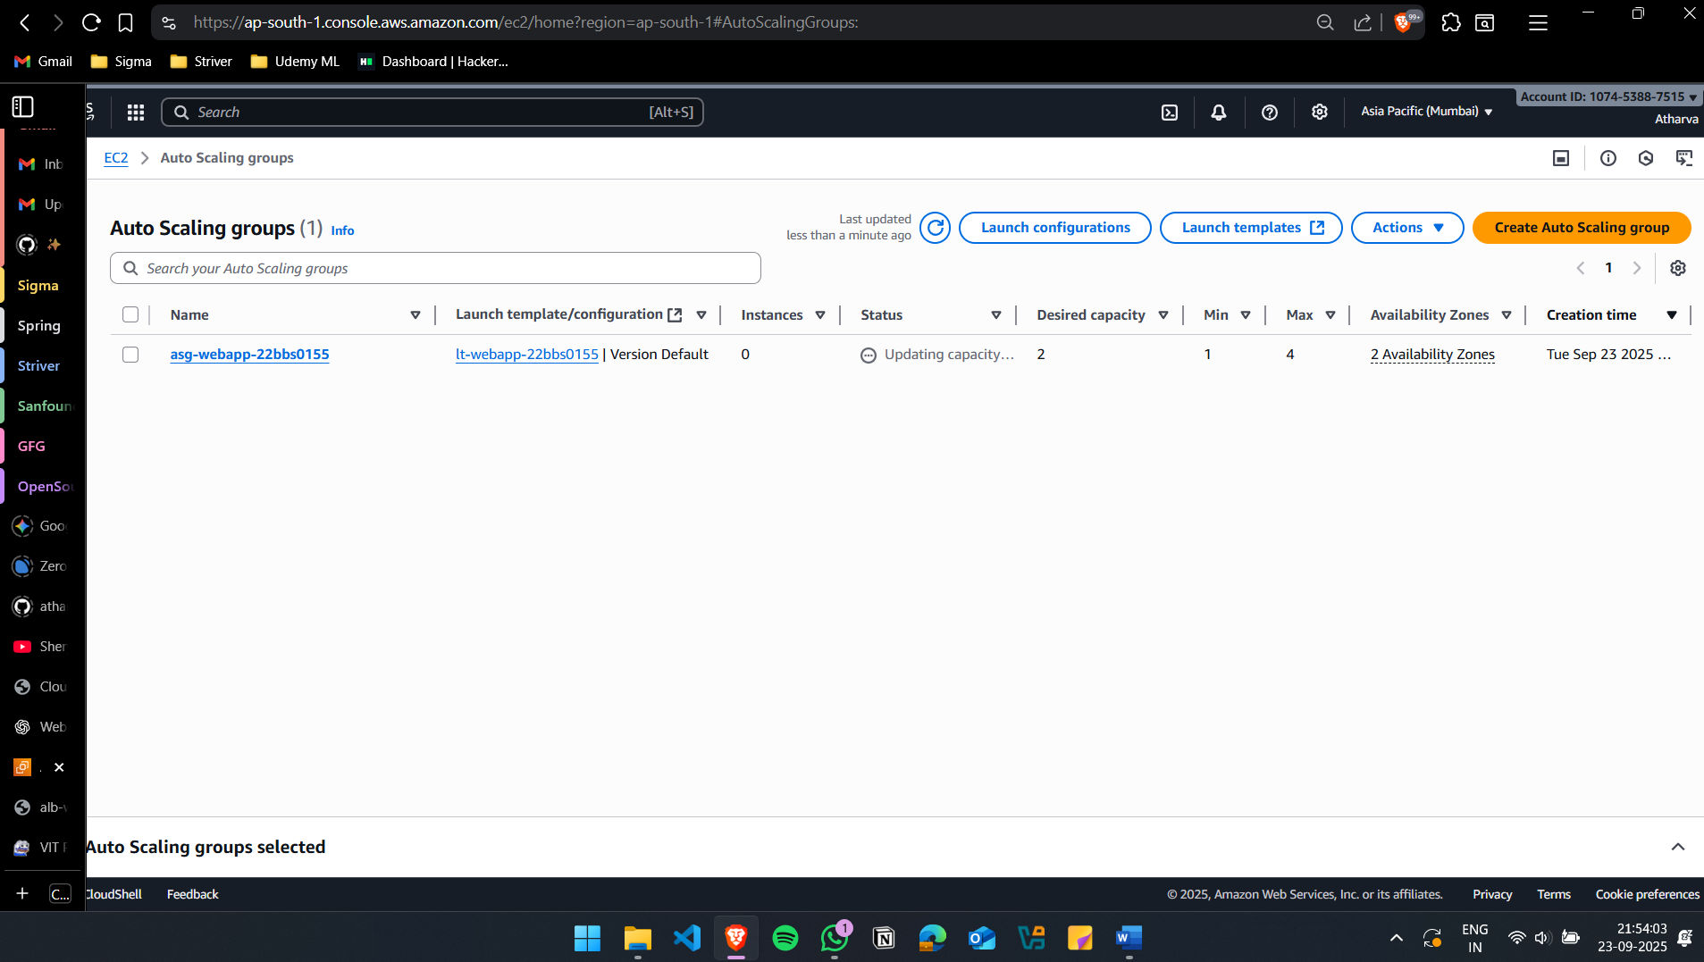
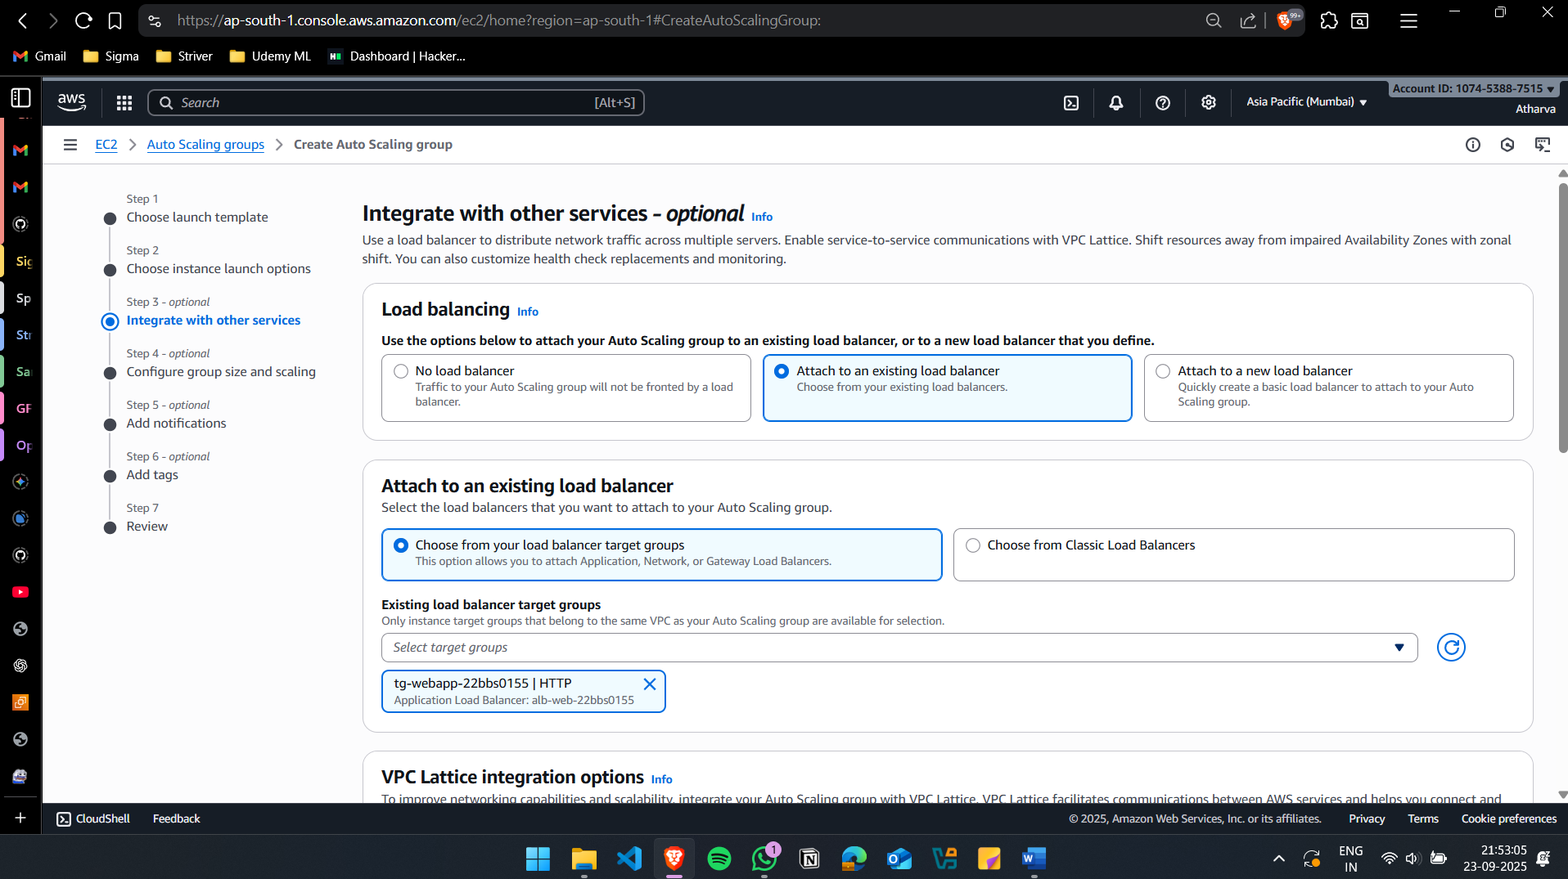

Create Scaling Policy
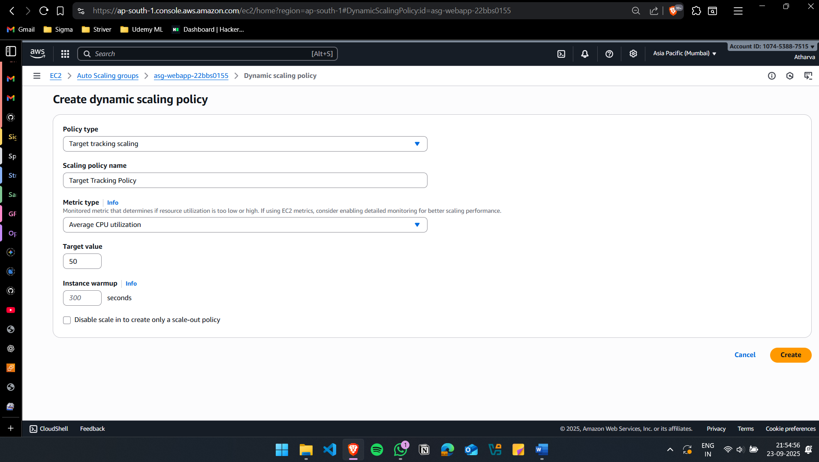
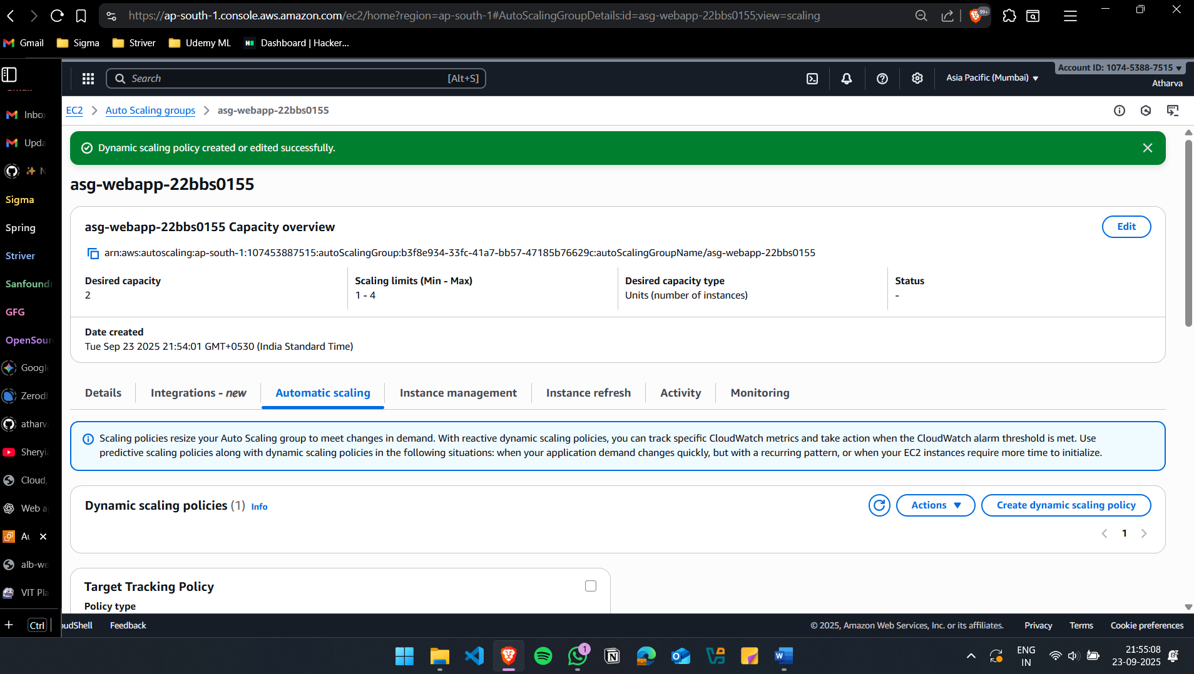

(v) Configure path-based routing: /auth requests go to the authentication service, /order requests go to the order processing service. Integrate the Load Balancer with Route 53 so that global users are routed to the nearest AWS region.
For this, instead of creating additional instances, I’m assuming web-a as Auth and web-2 as order.
Create new Target Group for Auth(Web-a)
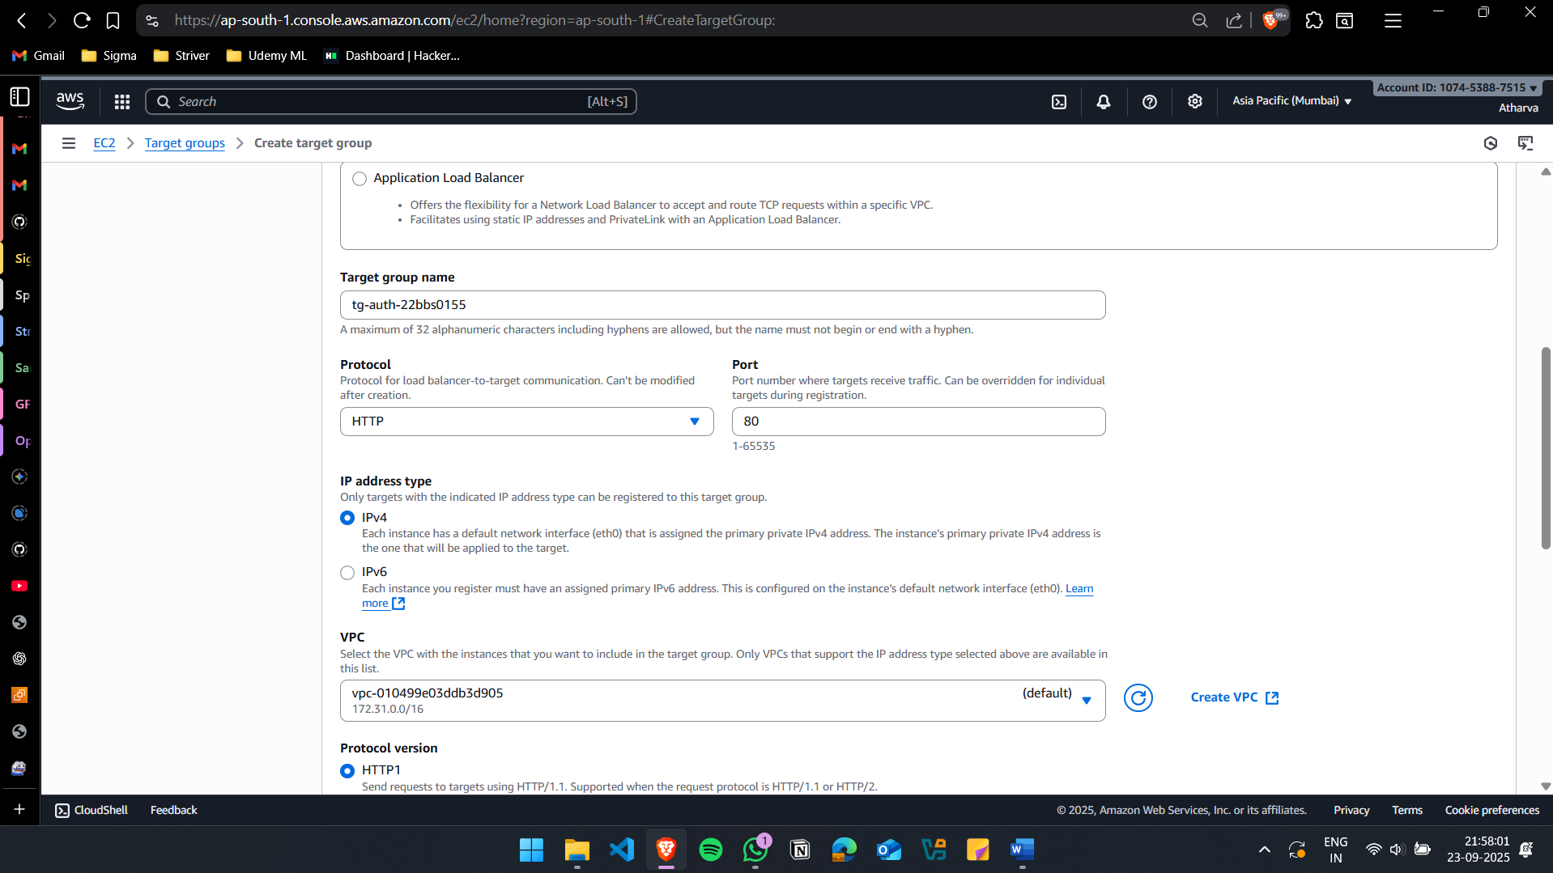
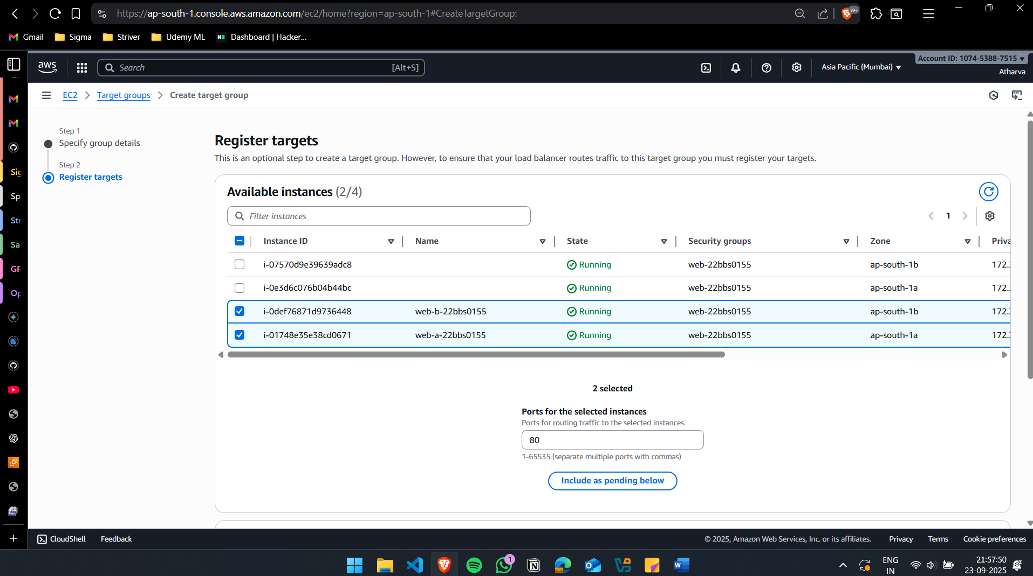

Create new Target Group for Order(Web-b)

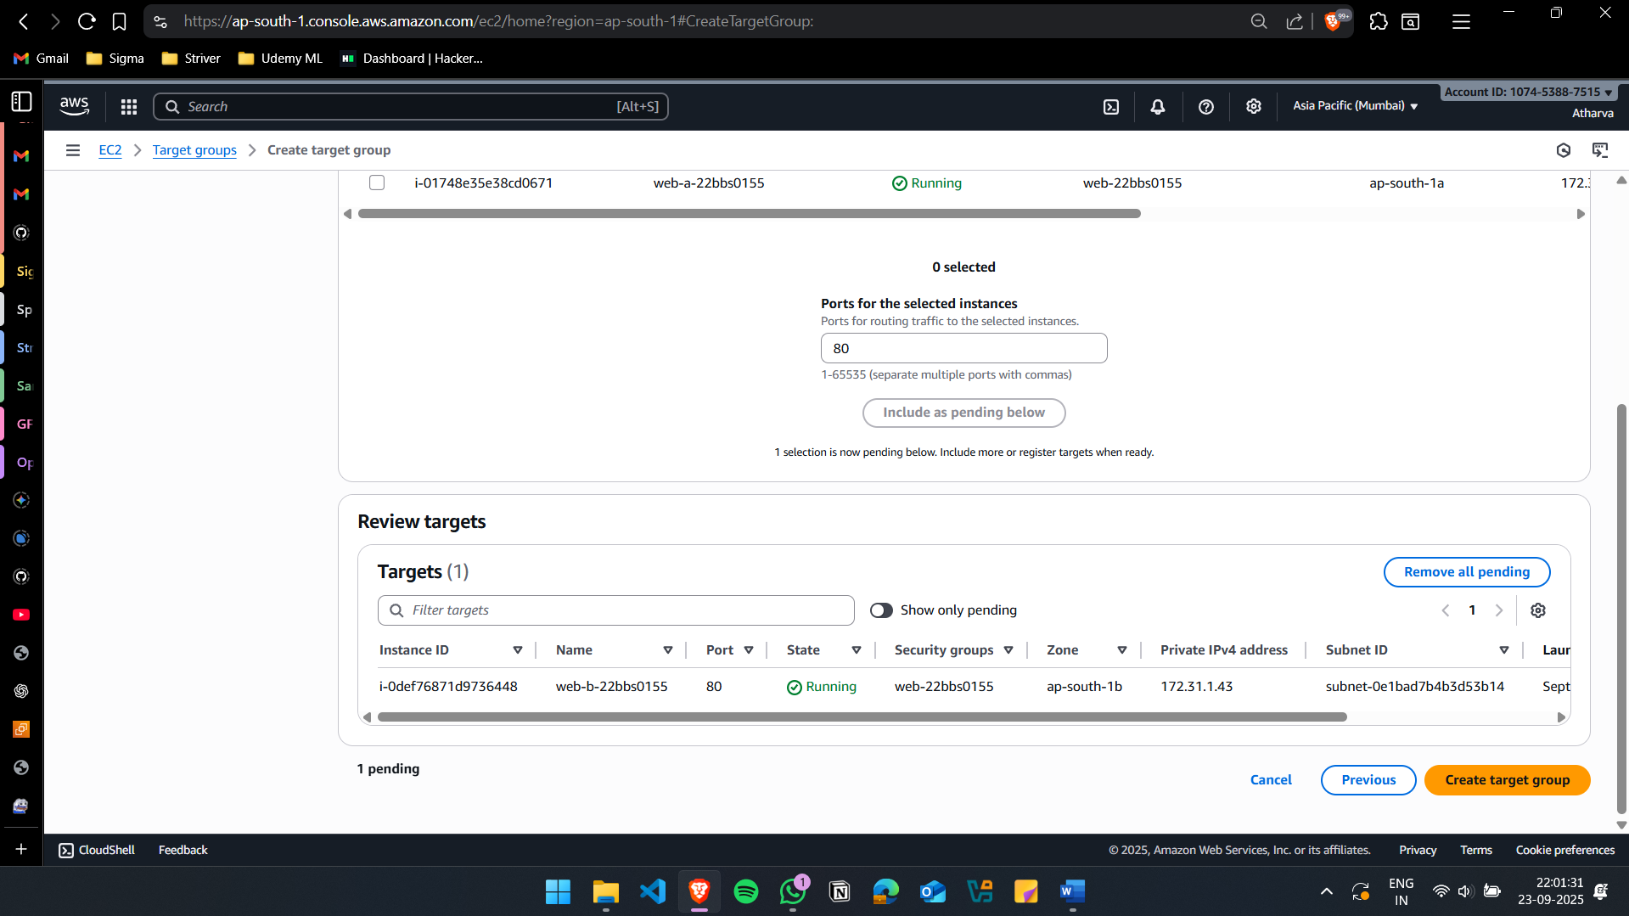
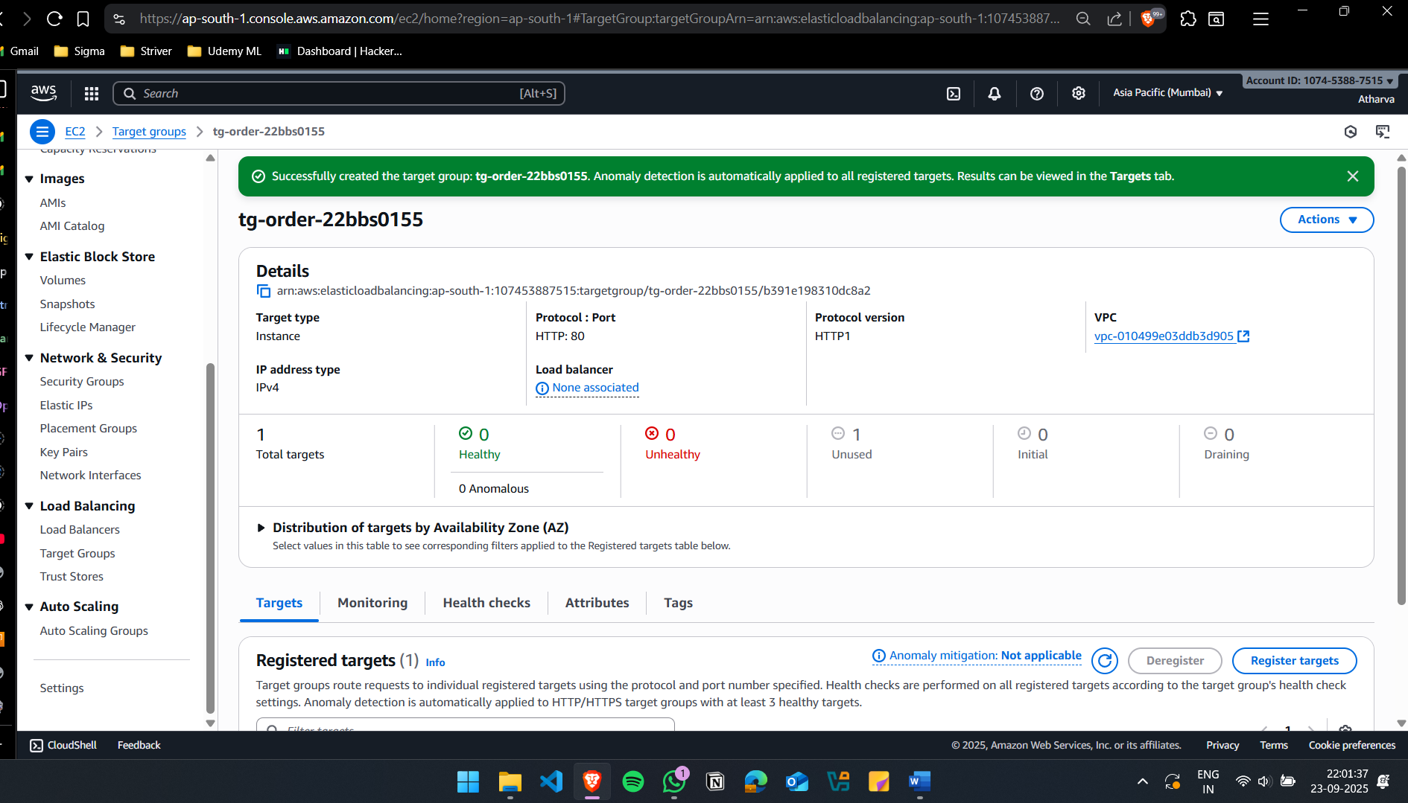

Add the rules to the ALB
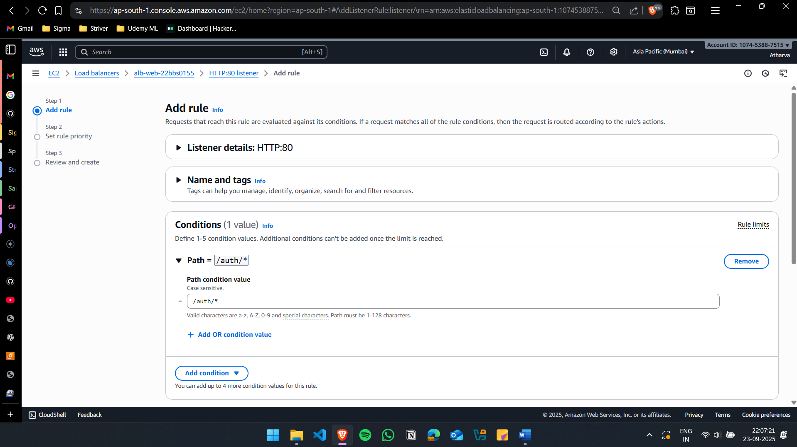
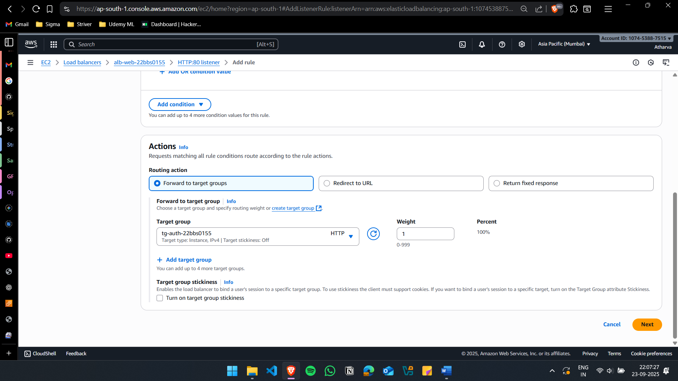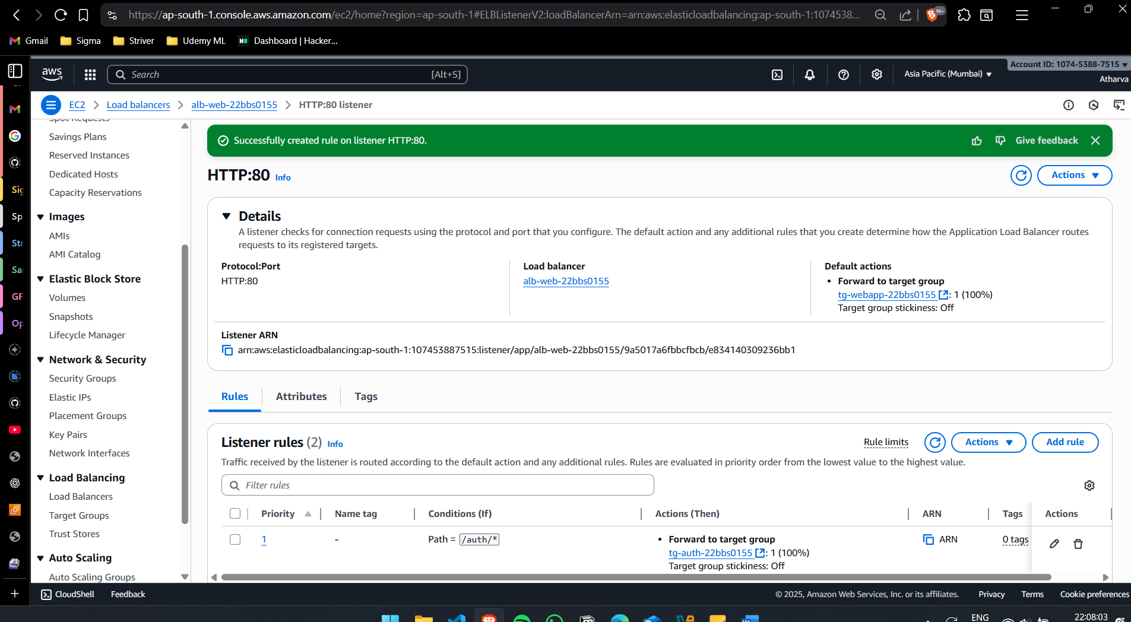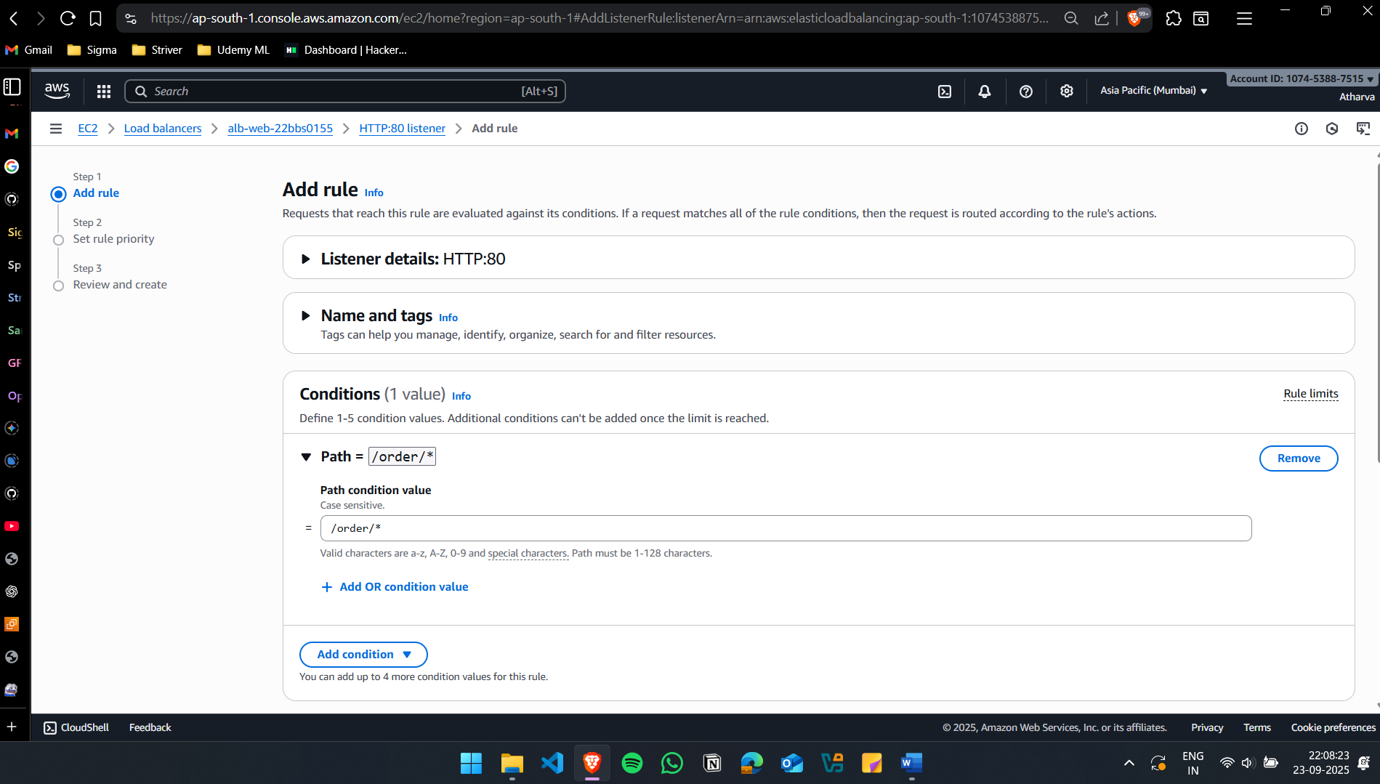
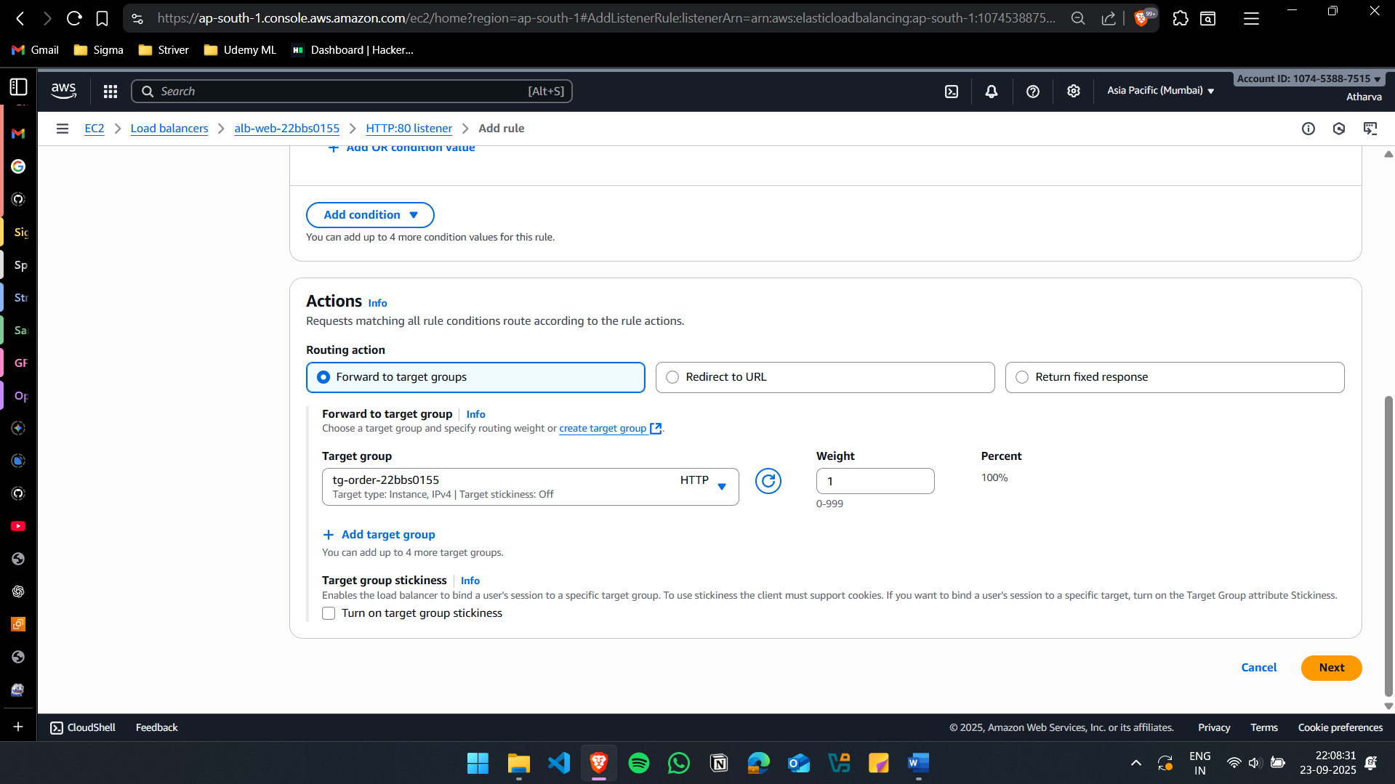
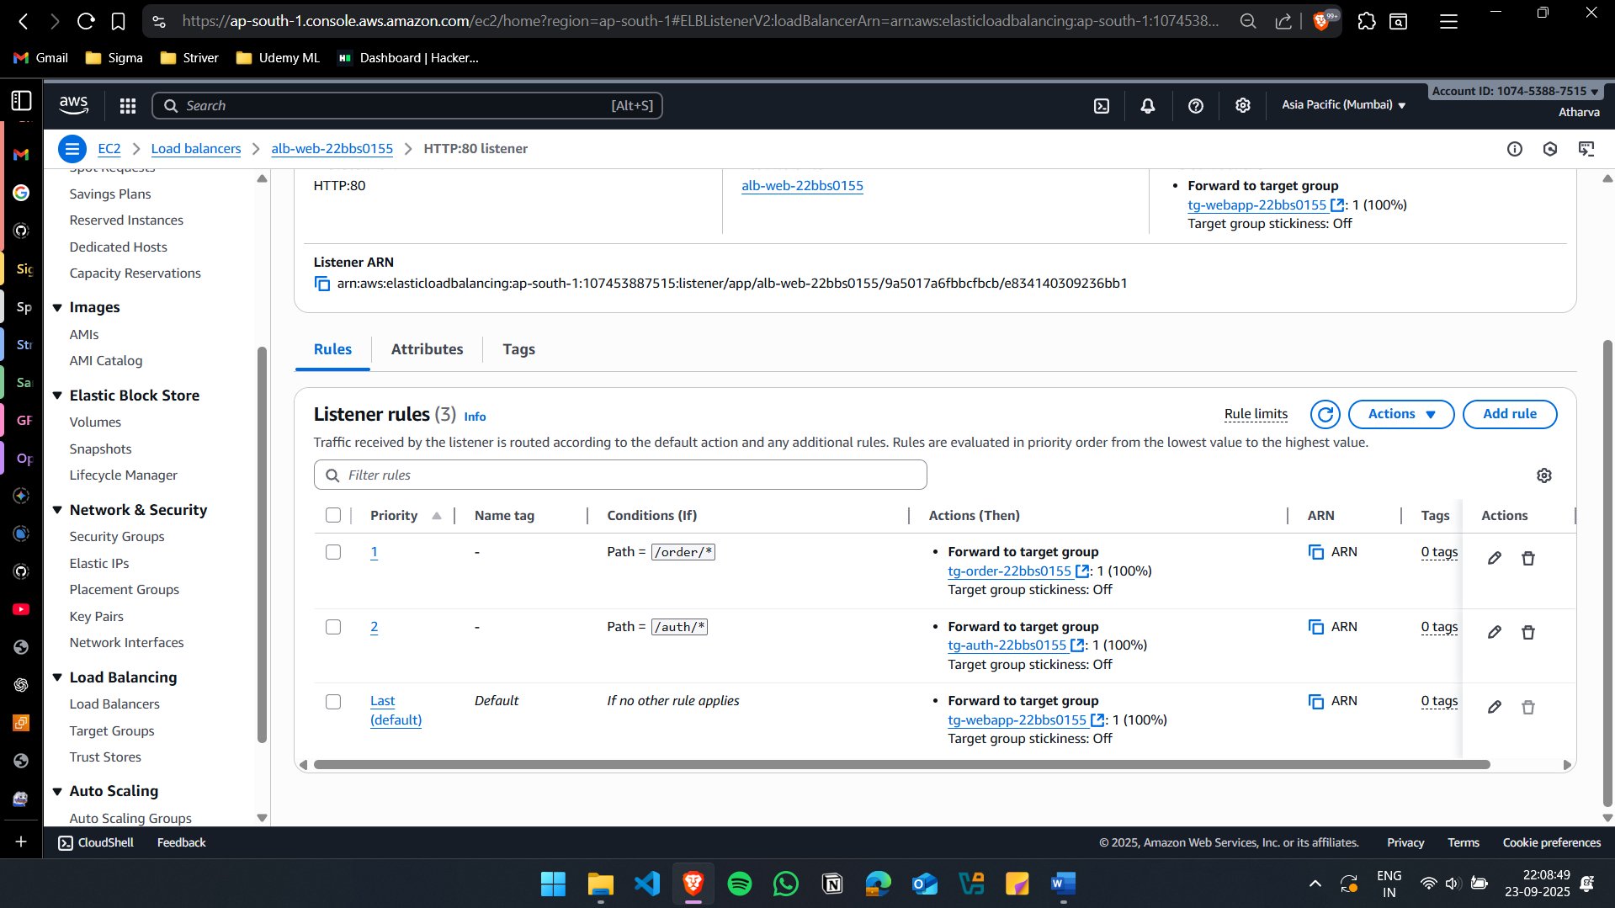

Route to the nearest hosted region
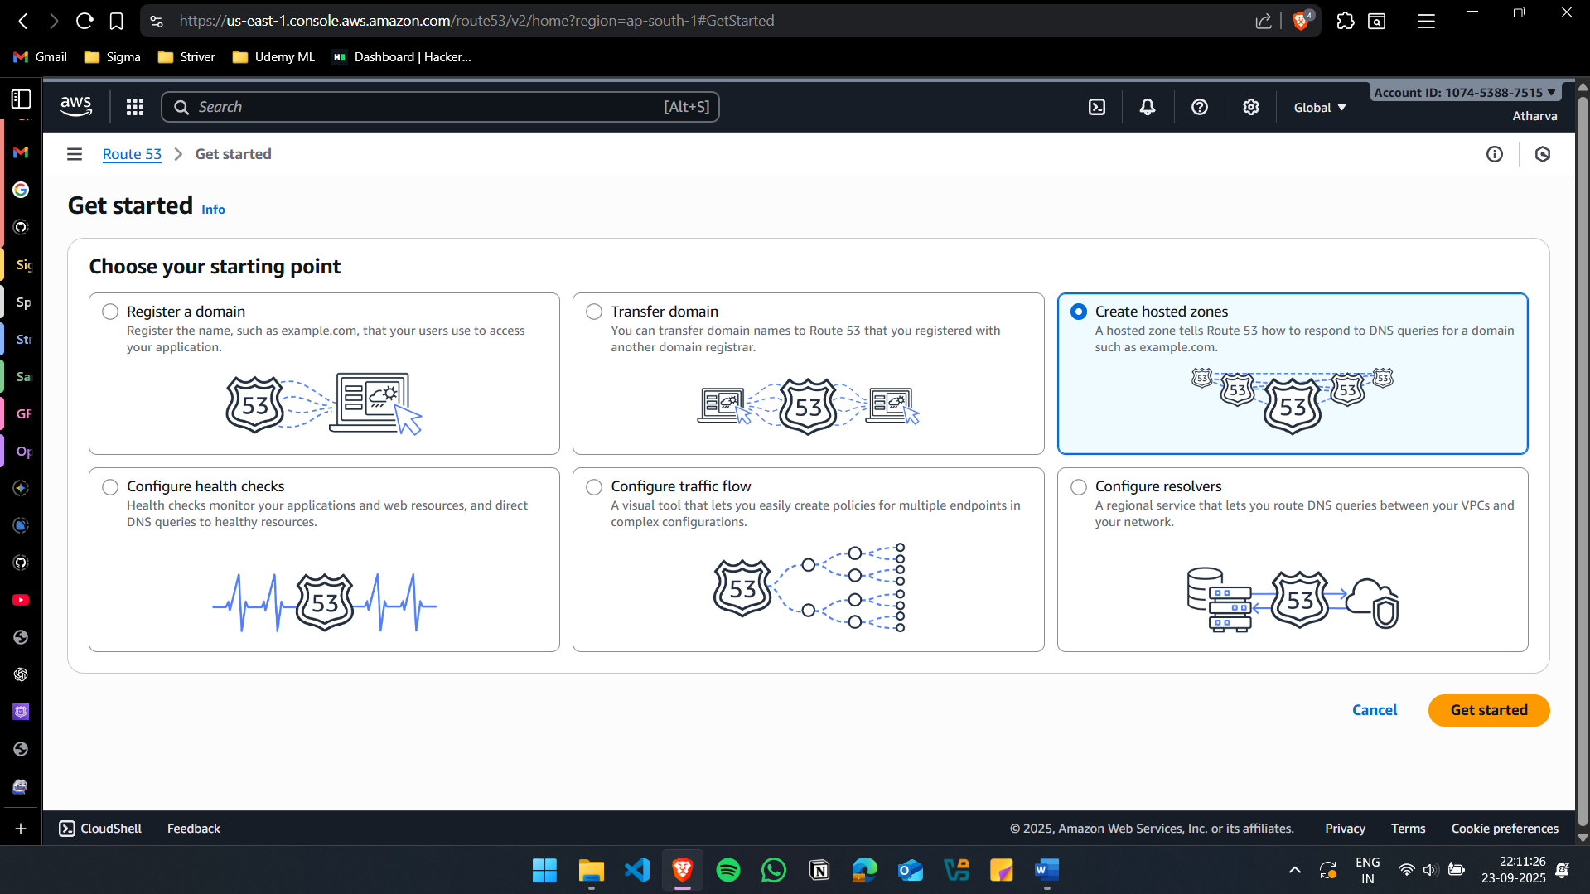
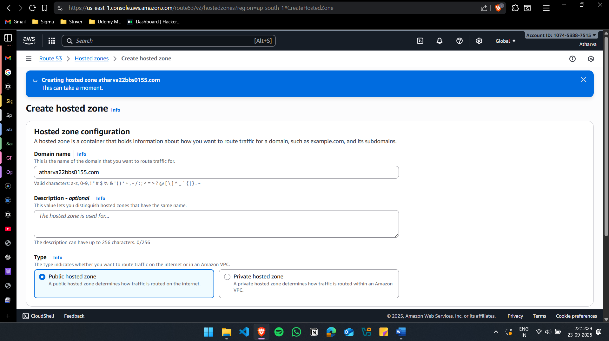
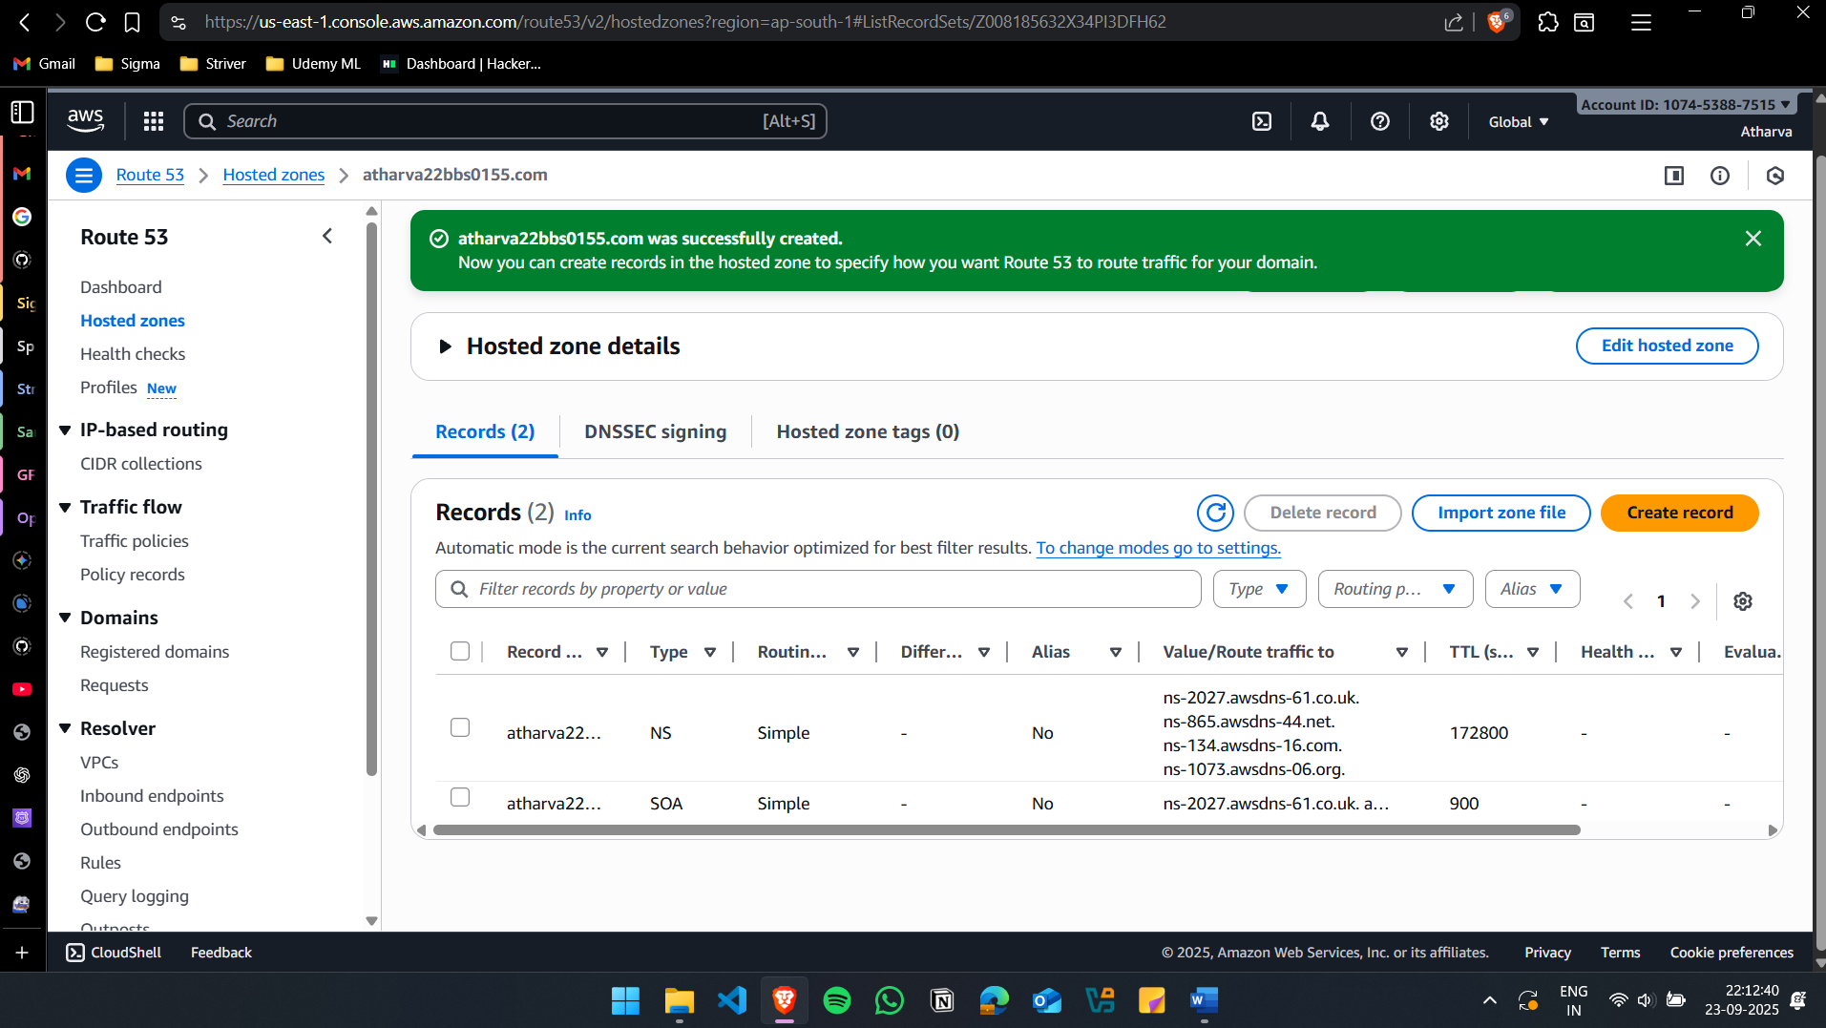

Create 2 records(mumbai and singapore)
